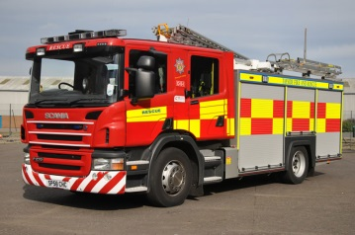Reception Spring 2 curriculum information

Our topic this half-term is… RESCUE! We will be looking at 6 different books over the coming weeks. Please see the list below.

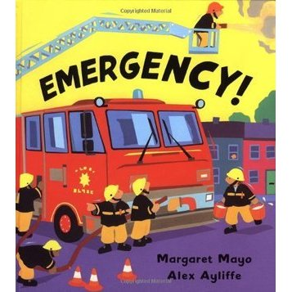Week 1: Duck in a truck – Jez Alborough

Week 2: Octonauts - Cbeebies

Week 3: Emergency! Emergency! - Margaret Mayo

Week 4: People who help us information books

Week 5: Supertato – Sue Hendra

Week 6: Superworm – Julia Donaldson

Things to try at home - How can I make these books more meaningful?

Week 1: Write lists of rhyming words e.g. duck and truck or goat and boat.

Week 2: Watch Octonauts together and draw your own rescue story.

Week 3: Design your emergency vehicle and write labels for the different parts e.g. wheels, siren etc.

Week 4: Research facts about the fire service on google. Make your own information book with words and pictures.

Week 5: Make your own Supertato using a real potato, paper, material and pens!

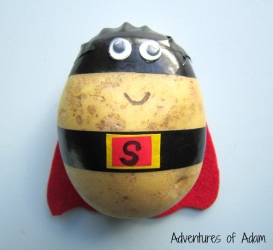Week 6: Write your own superhero rescue story… how does your hero stop the villain?

Maths focus

We will be looking at the following maths topics this half-term.

-2D and 3D shape hunt

-Addition and Subtraction

-Problem solving e.g. how plates for dinner?

-Capacity e.g. is the cup half full or full?

-Practise writing numbers 1-20.