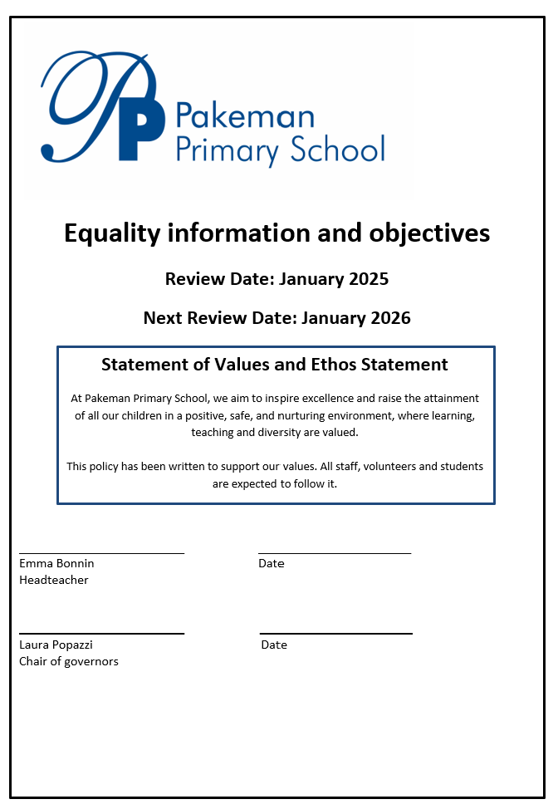

Contents
1. Aims 2
2. Legislation and guidance 2
3. Roles and responsibilities 3
4. Eliminating discrimination 3
5. Advancing equality of opportunity 3
6. Fostering good relations 3
7. Equality considerations in decision-making 4
8. Equality objectives 4
9. Monitoring arrangements 5
10. Links with other policies 5

1. Aims
Our school aims to meet its obligations under the Public Sector Equality Duty (PSED) by having due regard to the need to:
- Eliminate discrimination and other conduct that is prohibited by the Equality Act 2010
- Advance equality of opportunity between people who share a protected characteristic and people who do not share it
- Foster good relations across all characteristics – between people who share a protected characteristic and people who do not share it
Our school aims to promote respect for difference and diversity in accordance with our values, rules and motto.
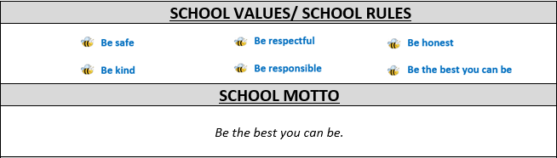

2. Legislation and guidance
This document meets the requirements under the following legislation:
- The Equality Act 2010, which introduced the Public Sector Equality Duty and protects people from discrimination
- The Equality Act 2010 (Specific Duties) Regulations 2011, which require schools to publish information to demonstrate how they are complying with the Public Sector Equality Duty and to publish equality objectives
This document is also based on Department for Education (DfE) guidance: The Equality Act 2010 and schools.

3. Roles and responsibilities
The governing board will:
- Ensure that the equality information and objectives as set out in this statement are published and communicated throughout the school, including to staff, pupils and parents
- Ensure that the published equality information is updated at least every year, and that the objectives are reviewed and updated at least every 4 years
- Delegate responsibility for monitoring the achievement of the objectives on a daily basis to the headteacher
The headteacher will:
- Promote knowledge and understanding of the equality objectives among staff and pupils
- Monitor success in achieving the objectives and report back to governors
All school staff are expected to have regard to this document and to work to achieve the objectives as set out in section 8.

4. Eliminating discrimination
The school is aware of its obligations under the Equality Act 2010 and complies with non-discrimination provisions.
Where relevant, our policies include reference to the importance of avoiding discrimination and other prohibited conduct.
Staff and governors are regularly reminded of their responsibilities under the Equality Act – for example, during meetings. Where this has been discussed during a meeting it is recorded in the meeting minutes.
New staff receive training on the Equality Act as part of their induction, and all staff receive refresher training every year through the Equality and Diversity Educare training.
The school has a designated member of staff for monitoring equality issues. This person regularly makes senior leaders and governors aware of any issues as appropriate.

5. Advancing equality of opportunity
As set out in the DfE guidance on the Equality Act, the school aims to advance equality of opportunity by:
- Removing or minimising disadvantages suffered by people that are connected to a particular characteristic they have (e.g. pupils with disabilities, or gay pupils who are being subjected to homophobic bullying)
- Taking steps to meet the particular needs of people who have a particular characteristic (e.g. enabling Muslim pupils to pray)
- Encouraging people who have a particular characteristic to participate fully in any activities (e.g. encouraging all pupils to be involved in the full range of school societies)
In fulfilling this aspect of the duty, the school will:
- Publish attainment data each academic year showing how pupils with different characteristics are performing
- Analyse the data referenced above to determine strengths and areas for improvement, implement actions in response and publish this information
- Make evidence available identifying improvements for specific groups (e.g. declines in incidents of homophobic or transphobic bullying)
- Publish further data about any issues associated with particular protected characteristics, identifying any issues which could affect our own pupils

6. Fostering good relations
The school aims to foster good relations between those who share a protected characteristic and those who do not share it by:
- Promoting tolerance, friendship and understanding of a range of religions and cultures through different aspects of our curriculum. This includes teaching in RE, citizenship and personal, social, health and economic (PSHE) education, but also activities in other curriculum areas. For example, as part of teaching and learning in English/reading, pupils will be introduced to literature from a range of cultures
- Holding assemblies dealing with relevant issues. Pupils will be encouraged to take a lead in such assemblies and we will also invite external speakers to contribute
- Working with our local community. This includes inviting leaders of local faith groups to speak at assemblies, and organising school trips and activities based around the local community
- Encouraging and implementing initiatives to deal with tensions between different groups of pupils within the school. For example, our school council has representatives from different year groups and is formed of pupils from a range of backgrounds. All pupils are encouraged to participate in the school’s activities, such as sports clubs. We also work with parents to promote knowledge and understanding of different cultures
- We have developed links with people and groups who have specialist knowledge about particular characteristics, which helps inform and develop our approach

7. Equality considerations in decision-making
The school ensures it has due regard to equality considerations whenever significant decisions are made.
The school always considers the impact of significant decisions on particular groups. For example, when a school trip or activity is being planned, the school considers whether the trip:
- Cuts across any religious holidays
- Is accessible to pupils with disabilities
- Has equivalent facilities for boys and girls

8. Equality objectives
Objective 1
Undertake an analysis of recruitment data and trends in regard to race, disability and any gender pay gap by July, and report on this to the staffing and pay sub-committee of the governing board.
Increase the representation of teachers from local Black and minority ethnic communities over a 4-year period (from this July to July in 4 years' time), so that this group increases from 10% to 25% of the teaching workforce.
Objective 2
Have in place a reasonable adjustment agreement for all staff with disabilities by July (that we are aware of), to meet their needs better and make sure that any disadvantages they experience are addressed.
Objective 3
Train all members of staff and governors involved in recruitment and selection on equal opportunities and non-discrimination by the beginning of the next academic year. Training evaluation data will show that 100% of those attending have a good understanding of the legal requirements.

Objective 4
Removing or minimising disadvantages suffered by pupils that are connected to a particular characteristic they have (e.g. pupils with disabilities, or gay pupils who are being subjected to homophobic bullying)

9. Monitoring arrangements
The headteacher will update the equality information we publish every year.
This document will be reviewed by the governing body at least every 2 years.
This document will be approved by the headteacher.

10. Equality data for staff
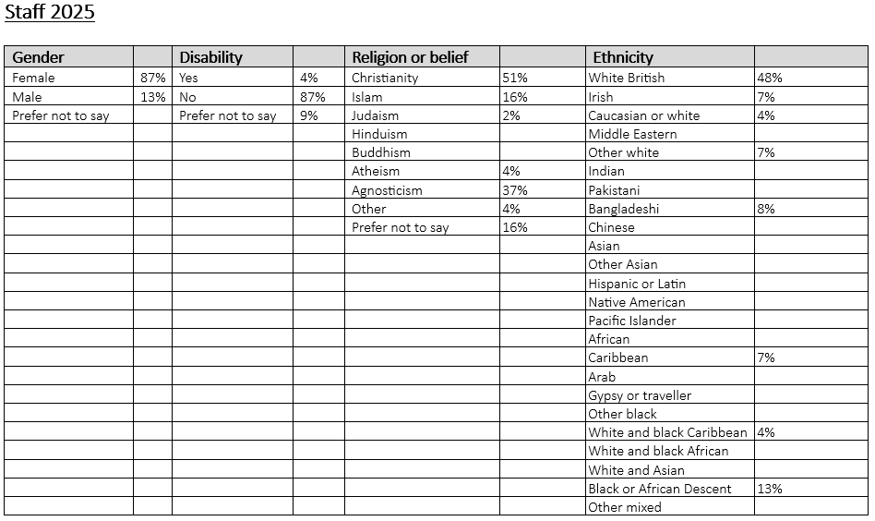
11. Equality data for pupils
