

Feedback Policy

Review Date: September 2024
Next Review Date: September 2025

_________________________ _______________________
Emma Bonnin Date
Headteacher

Ethos Statement
Pakeman School offers a positive, safe learning environment for its community, in which everyone has equal and individual recognition and respect. We celebrate success and are committed to the continuous improvement and fulfilment of potential in every child. We encourage increasing independence and self-discipline amongst the pupils. Everyone within the school has an important role to play in sharing responsibility for the development of this policy.

What is the purpose of the policy?

The purpose of this policy is to make explicit how staff mark children’s work and provide feedback. All members of staff are expected to be familiar with the policy and to apply it consistently.

Tracking progress and attainment:

- It is essential that teachers have secure understanding of every child’s achievement and progress. At Pakeman we use a blend of summative and formative assessment to track pupil progress. Alongside NTS termly assessment weeks, we use writing samples and ongoing teacher assessment.

- Complete a gap analysis for reading and maths NTS tests every term. Ensure this is recorded in writing in a form that suits your team. This will inform future planning.

- For maths, NTS papers are used to:
  - level each child accurately
  - form a gap analysis
  - inform future planning

- For writing, checklists are used to:
  - level each child accurately
  - form a gap analysis
  - inform future planning

- For reading:
- NTS papers are used to level children accurately, form a gap analysis and inform future planning
- Phonics screening, PM benchmarking and DSR are used as formative assessment in KS1

- For topic:
- Complete end of unit assessments of each foundation subject and science based on the key learning on the progression of knowledge documents. Mark these with a blue pen

- For EYFS:
- Target Tracker is used to record observations and work samples alongside termly assessments

What is the teacher and TA expected to do?

Every day, Teacher and TA to have a focus table each. They are expected to:
- Give targeted support and verbal verback to the children on this table
- Highlight the work in green and blue - Green highlighter = met the success criteria Blue highlighter = improvement needed
- Ensure children respond to blue feedback within the lesson
- Oversee the rest of the learners to inform their whole class objective analysis. This helps motivate pupils and picks up on misconceptions
- Teachers/LSAs must ensure that they look at all books to inform the maths misconception intervention for that afternoon.
- For writing, teachers complete a writing checklist for each writing portfolio piece. A minimum of 6 portfolio pieces should be completed during the school year.
- Over the course of the week the teacher will have had every child as a focus child in each core subject.
- LSAs should work with a different focus table each day.

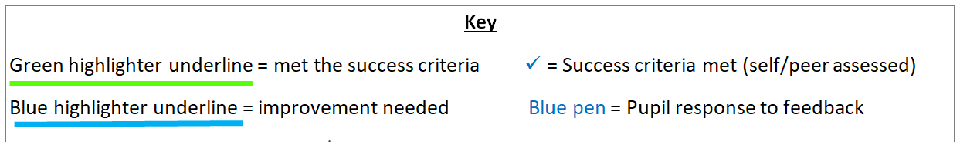

What are the children expected to do?
- When a child’s work is highlighted blue, in their feedback they are expected to edit and improve (using blue pen from Year 2 to Year 6)
- In KS2, as part of peer-assessment and self-assessment, children should tick the success criteria that they have met
- When class marking in Key Stage 2, children use a blue tick for a correct answer and a blue dot for a misconception.

What to include in teaching
- Success criteria:
- Success criteria will be explained at the start and reviewed at the end of the lesson
- In literacy, success criteria slips are regularly used
- In maths, big read and topic, the success criteria will be visible on the interactive white board but not on individual slips
- Ensure that the success criteria is visual for all Key Stage 1 pupils and SEND pupils in Key Stage 2

- Ensure that there are regular opportunities for children to learn how to edit or correct their work
- Look for opportunities to share pupils’ work to celebrate successes or to address misconceptions
- Use class marking as a tool for maths fluency questions and closed reading questions (retrieval, word meaning etc.) with a blue pen
- Please ensure that teachers and LSAs work with SEND pupils throughout the week
- Ensure that you have a focus table timetable for all of the adults in your class

Reminder
For feedback to be the most effective and to help the children improve in their learning it should be timely, consistent and immediate.

