Pupil premium strategy report 2023/2024

This statement details our school’s use of pupil premium (and recovery premium for the 2023 to 2024 academic year) funding to help improve the attainment of our disadvantaged pupils.

It outlines our pupil premium strategy, how we intend to spend the funding in this academic year and the effect that last year’s spending of pupil premium had within our school.

School overview

Detail | Data
School name | Pakeman Primary School
Number of pupils in school | 311
Proportion (%) of pupil premium eligible pupils | 52%
Academic year/years that our current pupil premium strategy plan covers (3 year plans are recommended) | Changed in September 2023 based on July 2023 data  2023 – 2024  2024 - 2025
Date this statement was published | September 2023
Date on which it will be reviewed | September 2024
Statement authorised by | Emma Bonnin (Headteacher)  Laura Popazzi  (Chair of governors)
Pupil premium lead | Tracey Gulliford
Governor / Trustee lead | Laura Popazzi

Funding overview

Detail | Amount
Pupil premium funding allocation this academic year | £254560
Recovery premium funding allocation this academic year | £24940
Pupil premium funding carried forward from previous years (enter £0 if not applicable) | £0
Total budget for this academic year | £279500
Total spent | £285838.41

Part A: Pupil premium strategy plan

Statement of intent

Our aim is to use the pupil premium funding to counter disadvantage and to ensure greater equity through:
- Ensuring and supporting great teaching
- Providing targeted academic interventions
- Using a wider range of strategies to overcome barriers to learning

Ensuring and supporting great teaching

We recognise the importance of ensuring all pupils, whatever their background or circumstance, are provided with an education of the highest quality. This will ensure that all our pupils are equipped with the knowledge and skills they will need to succeed in, and beyond school. Strategies to close achievement gaps between groups and individuals are an integral part of every lesson and evident across the curriculum. Within the classroom there is a clear focus on well planned and differentiated lessons that challenge and stretch all pupils. A programme of training supports staff to continually expand and experiment with a full range of teaching strategies and techniques to ensure the achievement gap is closed rapidly through the use of timely and appropriate interventions.
This will include:
- extensive gap analysis used to further inform teaching
- 1:1 and small group support within the class
- LSA and additional teacher support in class
- The employment of specialist teachers
- CPD for staff and collaborative practice, including team teaching, modelled lessons and best practice visits

Providing targeted academic interventions

For some children, high quality teaching in itself may not be enough and there is a need for additional, time-limited provision outside of normal classroom activities. There is extensive evidence supporting the impact of high quality one to one and small group tuition as a catch-up strategy. Programmes are likely to have the greatest impact where they meet a specific need, include regular sessions maintained over a sustained period and are carefully timetabled to enable consistent delivery. Effective interventions follow assessment, which can then be used to ensure that support is well-targeted and to monitor pupil progress.
This will include:
- 1:1 / small groups in English and maths
- additional learning time
- online 1:1 tutoring
- additional phonics
- speech and language support
- SEND / EAL support groups

Specific support needed for 2023/2024
- Whole school writing
- Whole school SPAG
- Reception reading, writing and maths
- GD reading and maths in Year 2
- Phonics support in Reception and Year 1
- Year 4 multiplication
- Year 3 and Year 4 maths
- Year 4 and Year 5 reading

Using a wider range of strategies to overcome barriers to learning

In addition to the strategies above, a range of other strategies can contribute to children’s success in school, such as improving attendance and punctuality, supporting positive behaviour, social and emotional skills and building parental engagement. Parents/carers play a key role in supporting children to learn at home and it is important for us to work together to support this.

This will include:
- a focus on improving attendance and punctuality
- providing curriculum enrichment opportunities
- support for wellbeing and mental health
- interventions to increase parental engagement and to ensure there is equity for pupils
- interventions focused on emotional regulation and social interaction
- whole school approach to trauma informed behaviours

Challenges

This details the key challenges to achievement that we have identified among our disadvantaged pupils.

Challenge number | Detail of challenge
1 | Lack of parental engagement, understanding of support systems and aspirations
2 | Mental health issues for the parents/carers and the child
3 | Lack of cultural capital and experiences
4 | Communication and social skills - Speech and language difficulties
5 | Exposure to gangs, crime, drug and alcohol abuse
6 | Housing issues, lack of space and overcrowding
7 | Financial issues
8 | Low attainment on entry

Intended outcomes

This explains the outcomes we are aiming for by the end of our current strategy plan, and how we will measure whether they have been achieved.

End of year data intended outcomes
EYFS Good Level of Development to be 68% for pupil premium children | Regular assessment weeks, data points and data tracking  Monitoring through observations, learning reviews, book looks, pupil voice and structured conversations.  Attendance and punctuality monitoring weekly with the headteacher and half termly with parents/ carers
Year 1 phonics to be 85% or above for pupil premium pupils
KS1 cumulative phonics to be 90% or above for pupil premium pupils
Year 2 attainment to be in line with national 70% in reading and maths, 65% in writing for pupil premium pupils
Year 2 greater depth attainment to be 15% or above for pupil premium pupils
Year 4 attainment in multiplication test to be above national for pupil premium pupils – 30% full marks
Year 3,4,5 and 6 attainment to be in line with national – above or at 70% in all reading, writing and maths
Attendance to be 96% or above for pupil premium children

Intended outcome | Monitoring | Link to aim:  - Great teaching  - Targeted interventions  - Wider strategies
Teaching is consistently good or better for pupil premium children | Monitoring through observations  Evaluation of regular CPD  Intervention observations and book looks  Feedback from trips using pupil voice  Monitoring in structured conversations  Systematic catch-up monitoring in interventions  Pupil voice monitoring for social and emotional interventions | 1
Pupil premium pupils are supported through interventions in all core subjects |  | 2
Pupil premium children benefit from a range of activities and experiences to broaden their experiences and curriculum |  | 3
Pupil premium children are supported emotionally and socially in order to fully access the curriculum |  | 2
Evidence
EFF Report on closing the attainment gap
https://educationendowmentfoundation.org.uk/support-for-schools/bitesize-support/closing-the-attainment-gap
NFER White rose in Reception
https://www.nfer.ac.uk/publications/evaluation-of-white-rose-maths-reception-jigsaw-programme/
NFER Year 2 tutoring impact
https://www.nfer.ac.uk/publications/independent-evaluation-of-the-national-tutoring-programme-year-2-impact-evaluation/

EEF impact of Covid on attainment
https://educationendowmentfoundation.org.uk/guidance-for-teachers/covid-19-resources/best-evidence-on-impact-of-covid-19-on-pupil-attainment
NFER report on the impact of covid on pupil attainment
https://www.nfer.ac.uk/media/4876/the_impact_of_covid_19_on_pupil_attainment.pdf
Impact of Covid on the disadvantaged gap
https://committees.parliament.uk/writtenevidence/5866/pdf/

Activity in this academic year

This details how we intend to spend our pupil premium (and recovery premium funding) this academic year to address the challenges listed above.

- Lack of parental engagement, understanding of support systems and aspirations
- Mental health issues for the parents/carers and the child
- Lack of cultural capital and experiences
- Communication and social skills - Speech and language difficulties
- Exposure to gangs, crime, drug and alcohol abuse
- Housing issues, lack of space and overcrowding
- Financial issues
- Low attainment on entry

Ensuring and supporting great teaching

Activity | Cost | Challenge number(s) addressed
Teaching monitoring and support – collaborative work – gap analysis – lesson study and best practice | Team leader TLR – 51% of TLR for 4 people  51%  £9948.64 | All
Leadership development training | Cost of Middle leaders training and NPQ training  51% of 9 days of DH  NPQ fully funded  £5290.25 | All
External validation - Local authority and consultant support | Reading, Maths and EYFS local authority moderations – 51%  £2371.50  Writing external consultant – Patric - 51% £1350  Writing specialist support - 51%  £750  Teaching and learning reviews - 51%  £1500 | All
Extensive gap analysis used to further inform teaching  Cost of learning by questions | LSA release time – 51% of 12 days a year for 6 people  £5257.44  Learning by questions software – 51%  £765 | All
The employment of specialist teachers | Music, PE, Spanish and Drama/Movement  51% of all  £13658.82 music  £17531 PE  Other subjects – funded | 3
1:1 and small group support within the class and LSA support in class | LSA, HLTAs and additional teacher support  51%  LSAs £93,446  HLTAs £42980.76  Additional teachers £88,949 | 1
CPD for staff and collaborative practice, including team teaching, modelled lessons and best practice visits | 51% of Future zone membership cost for training and networking  £2040 | 1 and 4

Providing targeted academic interventions

Activity | Evidence that supports this approach | Challenge number(s) addressed
1:1 / small groups in English and maths | 51% of LSAs. HLTAs and additional teachers cost in all year groups  (already accounted for above) | 1
Additional learning time – boosters | Funded by Richard Reeves | X
Online 1:1 tutoring | Funded by Richard Reeves | X
Additional phonics group work | 51% of phonics TLR = already accounted for  51% of 4 hours a week cost - (already accounted for above) | 1
Speech and language support | Funded by local authority | 1 and 4
SEND / EAL support groups | 51% of LSAs. HLTAs and additional teachers cost in all year groups  (already accounted for above)  51% of additional LSA costs for SEND | 1 and 4
CGP books for homework and differentiation | 51% of cost of books | 1
Pupil progress interventions | 3 hours a week of DH cost – 51%  Already accounted for | All

Using a wider range of strategies to overcome barriers to learning

Activity | Evidence that supports this approach | Challenge number(s) addressed
Focus on improving attendance | 51% of 5 hours a week of attendance and punctuality lead  51% of 2H of our Child and Family Support worker’s time  (already accounted for above) | 1
Providing curriculum enrichment opportunities and targeted financial support | 51% of trip costs for the year  Bringing literacy to life experiences – funded by fundraising  School funded place for 2 pupil premium children on school journey  51% of Young Shakespeare company  51% of Now Press Play  (already accounted for above) | 3
SEMH interventions for children who are not accessing the curriculum to their full potential | 51% of SEMH interventions (3 days between both CFSW – 5 days funded by Richard Reeves)  (already accounted for above) | 2
Support for wellbeing and mental health | Training for staff to support in class throughout the day  Funded by local authority | 2
Interventions to increase parental engagement and to ensure there is equity for pupils | 51% of 1/10 of our Child and Family Support worker’s time for coffee mornings and workshops  Partly funded by Richard Reeves | All
Weekly pastoral care meetings | 51% of 2 hours of H, DH and AH  (already accounted for above) | 1

Total budgeted cost: £285838.41

Part B: Review of outcomes for 2024 results

Data July 2024
EYFS
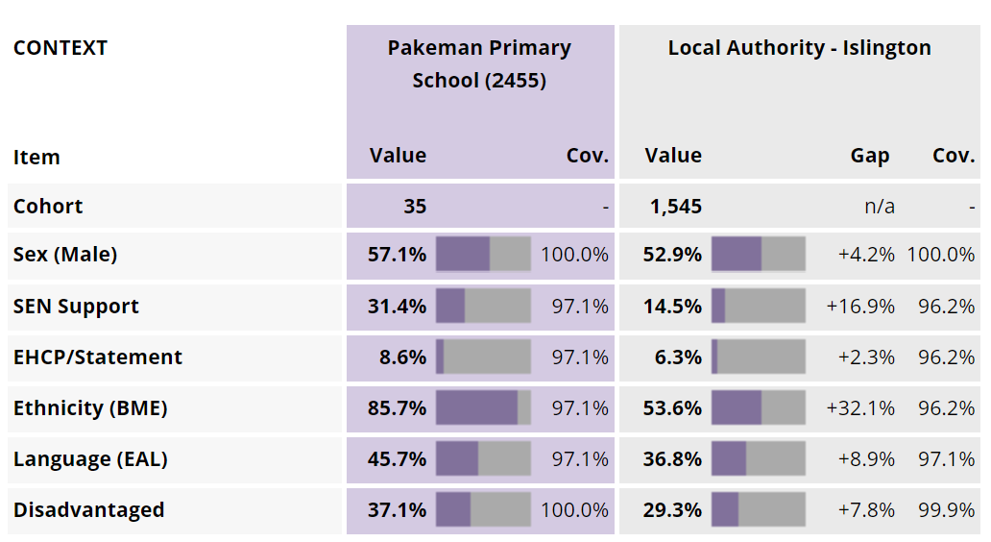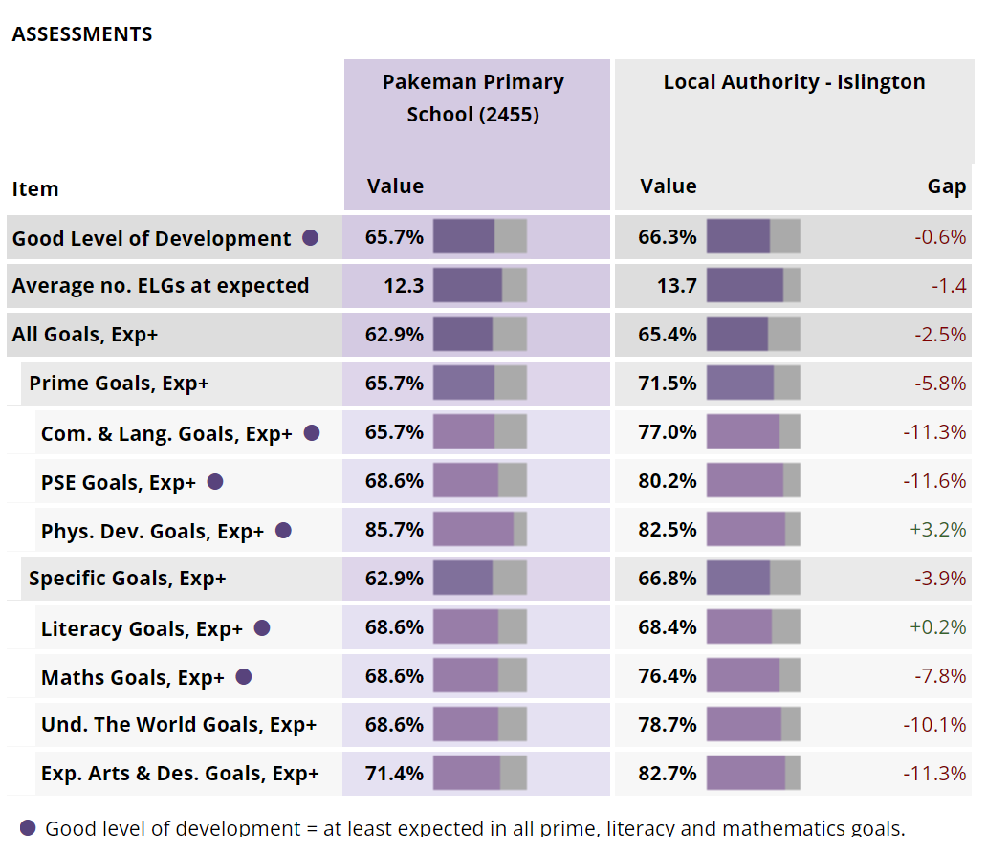

 | Pakeman  July 2023 | Islington 2024
EYFS GLD | 65.7% | 66.3%

Phonics – Year 1 and 2

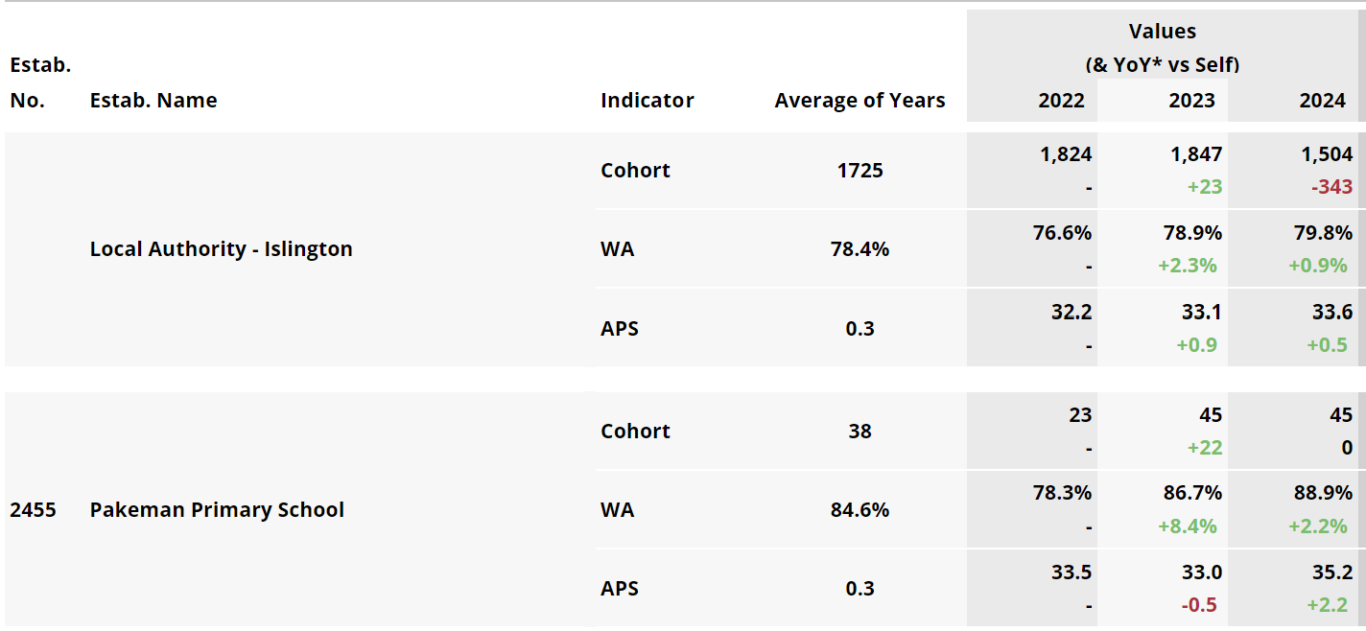

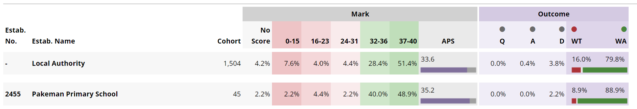

 | Pakeman  July 2023 | Islington 2024
Year 1 phonics | 88.9% | 79.8%
End of KS1 phonics | 95.5% | 88.6%

 | All | Disadvantaged | Non disadvantaged | Boy | Girl
Year 1 Phonics | 89% | 92% | 84% | 96% | 83%

Year 4 Multiplication test

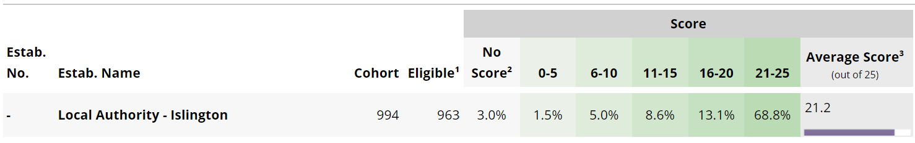

 | Pakeman  July 2024 | Islington 2024 | National 2024
Multiplication test  (Year 4) | 61% full marks  86% on 21+ | 68.8% on 21-25 | 27% full marks

KS2 SATs – Year 6

Discount one pupil – Liyana

Pakeman
July 2024
Year 6 reading | 73%  32%
Year 6 maths | 77%  29%
Year 6 writing | 70%  3%
Year 6 combined | 67%
Year 6 SPAG | 68%  39%

Other year groups

 | Reading | Writing | Maths | Combined
Year 1 | 71%  33% | 64%  24% | 76%  36% | 58%
Year 2 | 84%  31% | 62%  27% | 76%  22% | 60%
Year 3 | 64%  33% | 64%  19% | 67%  42% | 56%
Year 4 | 80%  46% | 77%  21% | 82%  52% | 71%
Year 5 | 71%  36% | 67%  7% | 69%  31% | 54%

