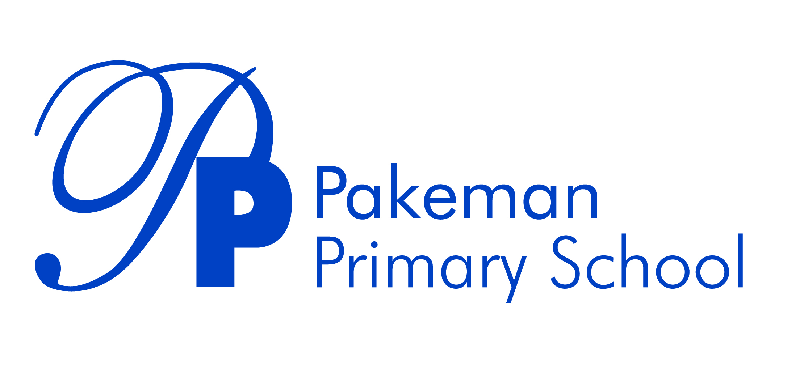

**Parents/Carers Acceptable Use Policy**

**Review Date: January 2025**

**Next Review Date: January 2026**

_________________________ _______________________

Emma Bonnin Date

Headteacher

# Background

**Ethos Statement**

Pakeman School offers a positive, safe learning environment for its community, in which everyone has equal and individual recognition and respect. We celebrate success and are committed to the continuous improvement and fulfilment of potential in every child. We encourage increasing independence and self-discipline amongst the pupils. Everyone within the school has an important role to play in sharing responsibility for the development of this policy.

We ask all children, young people and adults involved in the life of Pakeman Primary School to sign an Acceptable Use Policy (AUP) to outline how we expect them to behave when they are online, and/or using school networks, connections, internet connectivity and devices, cloud platforms and social media (both when on school site and outside of school).

Your child has also signed an AUP which is available in class and on our website.

We tell your children that **they should not behave any differently when they are out of school or using their own device or home network.** What we tell pupils about behaviour and respect applies to all members of the school community, whether they are at home or school:

**“Treat yourself and others with respect at all times; treat people in the same way when you are online or on a device as you would face to face.”**

# Where can I find out more?

You can read Pakeman’s full Computing – E.Safety Policy on our website for more detail on our approach to online safety and links to other relevant policies (e.g. Safeguarding Policy, Behaviour Policy, etc). If you have any questions about this AUP or our approach to online safety, please speak to Emma Bonnin (Headteacher).

# What am I agreeing to?

1. I understand that Pakeman’s uses technology as part of the daily life of the school when it is appropriate to support teaching & learning and the smooth running of the school, and to help prepare the children and young people in our care for their future lives.
2. I understand that the school takes every reasonable precaution to keep pupils safe and to prevent pupils from accessing inappropriate materials, including behaviour policies and agreements, physical and technical monitoring, education and support and web filtering. However, the school cannot be held responsible for the nature and content of materials accessed through the internet and mobile technologies, which can sometimes be upsetting.
3. I understand that internet and device use in school, and use of school-owned devices, networks and cloud platforms out of school may be subject to filtering and monitoring. These should be used in the same manner as when in school, **including during any remote learning periods.**
4. I will promote positive online safety and model safe, responsible and positive behaviours in my own use of technology, including on social media: not sharing other’s images or details without permission and refraining from posting negative, threatening or violent comments about others, including the school staff, volunteers, governors, contractors, pupils or other parents/carers.
5. The impact of social media use is often felt strongly in schools, which is why we expect certain behaviours from pupils when using social media. I will support the school’s social media policy and not encourage my child to join any platform where they are below the minimum age.
6. I will follow the school’s e.safety and safeguarding policy, which outlines when I can capture and/or share images/videos. I will not share images of other people’s children on social media and understand that there may be cultural or legal reasons why this would be inappropriate or even dangerous. The school sometimes uses images/video of my child for internal purposes such as recording attainment, but it will only do so publicly if I have given my consent on the relevant form.
7. I understand that for my child to grow up safe online, they will need positive input from school and home, so I will talk to my child about online safety and refer to parentsafe.lgfl.net for advice and support on safe settings, parental controls, apps and games, talking to them about life online, screentime and relevant topics from bullying to accessing pornography, extremism and gangs, sharing inappropriate content etc...
8. **I understand that my child needs a safe and appropriate place to do remote learning if school or bubbles are closed (similar to regular online homework). When on any video calls with school, it would be better not to be in a bedroom but where this is unavoidable, my child will be fully dressed and not in bed, and the camera angle will point away from beds/bedding/personal information etc. Where it is possible to blur or change the background, I will help my child to do so.**
9. **If my child has online tuition for catchup after lockdown or in general, I will refer to** the [Online Tutors – Keeping children Safe](https://static.lgfl.net/LgflNet/downloads/online-safety/posters/LGfL-DigiSafe-Online-Tutors-Safeguarding-Guidance.pdf) poster and **undertake necessary checks where I have arranged this privately, ensuring they are registered/safe and reliable, and for any tuition to remain in the room where possible, ensuring my child knows that tutors should not arrange new sessions or online chats directly with them**.
10. I understand that whilst home networks are much less secure than school ones, I can apply child safety settings to my home internet. Internet Matters provides guides to help parents do this easily for all the main internet service providers in the UK. There are also child-safe search engines e.g. swiggle.org.uk and YouTube Kids is an alternative to YouTube with age appropriate content.
11. I understand that it can be hard to stop using technology sometimes, and I will talk about this to my children, and refer to the principles of the Digital 5 A Day: [childrenscommissioner.gov.uk/our-work/digital/5-a-day/](https://www.childrenscommissioner.gov.uk/our-work/digital/5-a-day/)
12. I understand and support the commitments made by my child in the Acceptable Use Policy (AUP) which they have signed, and I understand that they will be subject to sanctions if they do not follow these rules.
13. I can find out more about online safety at Pakeman by reading the full e.safety and Safeguarding Policy here and can talk to Emma Bonnin if I have any concerns about my child/ren’s use of technology, or about that of others in the community, or if I have questions about online safety or technology use in school.

______________________________________________________________________

**ONLY RETURN IF YOU DO NOT AGREE**

**I/we have read, understood and DO NOT agreed to this policy.**

**Signature/s: _______________________________________**

**Name/s of parent / guardian: _______________________________________**

**Parent / guardian of: _______________________________________**

**Date: _______________________________________**