

RSE Policy
(Relationships and Sex Education)

Review Date: September 2024
Next Review Date: September 2025

_________________________ _______________________
Emma Bonnin Date
Headteacher

_________________________ _______________________
Laura Popazzi Date
Chair of Governors

Statement of Values and Ethos Statement
At Pakeman Primary School, we aim to inspire excellence and raise the attainment of all our children in a positive, safe, and nurturing environment, where learning, teaching and diversity are valued.

This policy has been written to support our values. All staff, volunteers and students are expected to follow it.

Contents

1. Aims 3
2. Statutory requirements 3
3. Policy development 4
4. Definition 4
5. Curriculum 5
6. Delivery of RSE 5
7. Roles and responsibilities 6
8. Parents’ right to withdraw 7
9. Training 7
10. Monitoring arrangements 7

Aims

The aims of relationships and sex education (RSE) at our school are to:

- Provide a framework in which sensitive discussions can take place
- Prepare pupils for puberty, and give them an understanding of sexual development and the importance of health and hygiene
- Help pupils develop feelings of self-respect, confidence and empathy
- Create a positive culture around issues of sexuality and relationships
- Teach pupils the correct vocabulary to describe themselves and their bodies

Statutory requirements

As a maintained primary school we must provide relationships education to all pupils as per section 34 of the Children and Social work act 2017.
However, we are not required to provide sex education but we do need to teach the elements of sex education contained in the science curriculum.
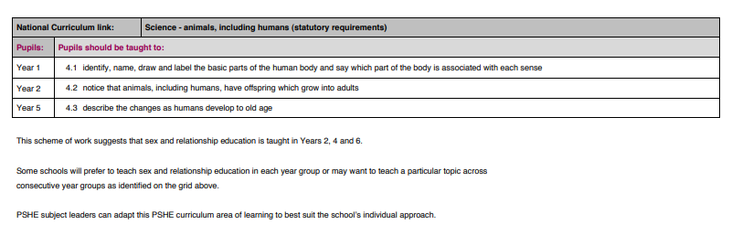
In teaching RSE, we must have regard to guidance issued by the secretary of state as outlined in section 403 of the Education Act 1996.

Policy development

This policy has been developed in consultation with staff, pupils and parents. The consultation and policy development process involved the following steps:
- Review – the Deputy Head teacher pulled together all relevant information including relevant national and local guidance

- Staff consultation – all school staff were given the opportunity to discuss the policy as part of our Equaliteach training.

- Parent/Carers consultation – parents and carers were invited to attend meetings about the curriculum and how it is taught throughout the school. The meetings explained the changes, explained the new curriculum, clarified misconceptions and concerns, and modelled 3 lessons for parents/carers.

- Pupil consultation – we discussed with children what they thought about their current RSE teaching, what they would like to be taught and how.

- Ratification – once amendments were made, the policy was shared with governors and ratified

Definition

RSE is about the emotional, social and cultural development of pupils, and, at primary age, involves learning about relationships. Sex education in primary school is not compulsory, other than the part which comes under the primary science curriculum.
RSE involves a combination of sharing information, and exploring issues and values.
RSE is not about the promotion of sexual activity.

Curriculum

Our curriculum is set out as per Appendix 1 but we may need to adapt it as and when necessary.
We have developed the curriculum in consultation with parents, pupils and staff, taking into account the age, needs and feelings of pupils. If pupils ask questions outside the scope of this policy, teachers will respond in an appropriate manner so they are fully informed and don’t seek answers online.
Primary sex education is not compulsory. It will focus on:
- Preparing boys and girls for the changes that adolescence brings
- How a baby is conceived and born

Delivery of RSE

RSE is taught within the personal, social, health and economic (PSHE) education curriculum. Biological aspects of RSE are taught within the science curriculum, and other aspects are included in religious education (RE).

Relationships education focuses on teaching the fundamental building blocks and characteristics of positive relationships including:
- Families and people who care for me
- Caring friendships
- Respectful relationships
- Online relationships
- Being safe
For more information about our RSE curriculum:
http://www.pakemanprimary.co.uk/wp-content/uploads/2021/05/PRIMARY-PSHE-SCHEME-OF-WORK.pdf

These areas of learning are taught within the context of family life taking care to ensure that there is no stigmatisation of children based on their home circumstances (families can include single parent families, LGBT parents, families headed by grandparents, adoptive parents, foster parents/carers amongst other structures) along with reflecting sensitively that some children may have a different structure of support around them (for example: looked after children or young carers).

Roles and responsibilities

7.1 The governing board

The governing board will hold the headteacher to account for the implementation of this policy.

  - The headteacher

The headteacher is responsible for ensuring that RSE is taught consistently across the school, and for managing requests to withdraw pupils from non-statutory/non-science components of RSE.

  - Staff

Staff are responsible for:
- Delivering RSE in a sensitive way
- Modelling positive attitudes to RSE
- Monitoring progress
- Responding to the needs of individual pupils
- Responding appropriately to pupils whose parents wish them to be withdrawn from the non-statutory/non-science components of RSE

Staff do not have the right to opt out of teaching RSE. Staff who have concerns about teaching RSE are encouraged to discuss this with the headteacher.
The staff responsible for teaching RSE are: all teachers in Year 2, Year 4 and Year 6, the deputy headteacher and the headteacher.

  - Pupils

Pupils are expected to engage fully in RSE and, when discussing issues related to RSE, treat others with respect and sensitivity.

Parents’ right to withdraw

Parents do not have the right to withdraw their children from relationships education.
Parents have the right to withdraw their children from the non-statutory/non-science components of sex education within RSE.
Requests for withdrawal should be put in writing using the form found in the Appendix of this policy and addressed to the headteacher.
Alternative work will be given to pupils who are withdrawn from sex education.

Training

Staff are trained on the delivery of RSE as part of their induction and it is included in our continuing professional development calendar.
The headteacher will also invite visitors from outside the school, such as school nurses or sexual health professionals, to provide support and training to staff teaching RSE if necessary.

Monitoring arrangements

The delivery of RSE is monitored by SLT through:
- Learning walks
- Discussions with pupils
Pupils’ development in RSE is monitored by class teachers as part of our internal assessment systems.
This policy will be reviewed by the headteacher annually. At every review, the policy will be approved by the governors.

Appendix : Parent/Carer form: withdrawal from sex education within RSE

To be completed by parents / CARERS
Name of child |  | Class
Name of parent |  | Date
Reason for withdrawing from sex education within relationships and sex education
Any other information you would like the school to consider
Parent / Carer signature

Curriculum Coverage:

