School Improvement Plan

2024/2025

School Improvement Plan Priorities
2024-2025
 | 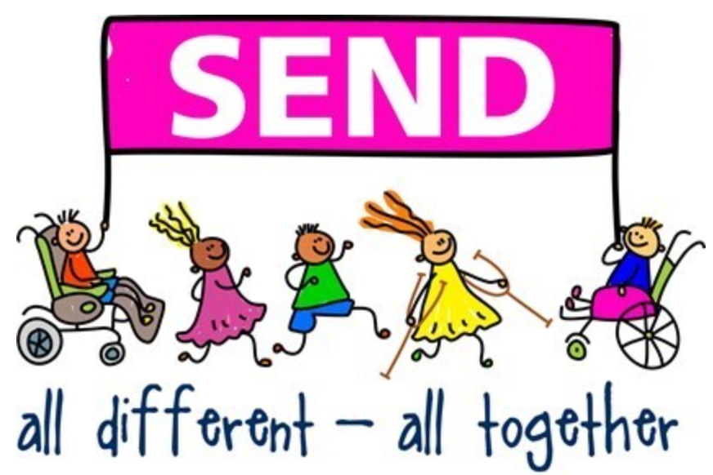 | 
1 – To ensure the school is financially stable (attracting external funding) | 2 – To ensure effective provision for all SEND pupils (universal approach to SEND, assessment, strategies…) | 3 – To increase engagement of parents/carers in the broader curriculum (clubs, homework, stalls, inclusion and diversity)
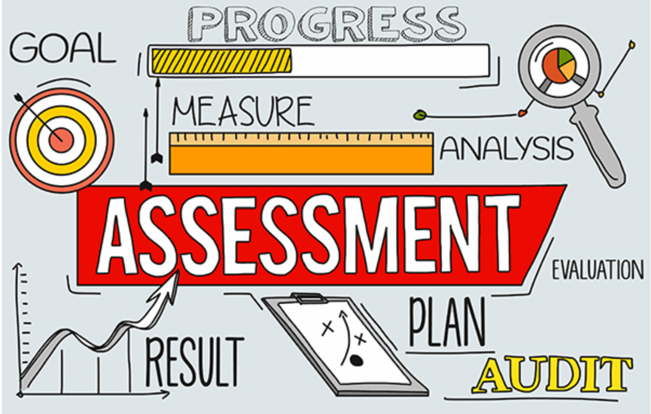 |  | 
4 – To ensure effective use of assessment in all subjects (particularly writing and foundation subjects) | 5 – To raise attainment in writing through new teaching strategies, effective interventions and impactful tracking (including mark making) | 6 – To ensure effective progress of children who are new to English

Priorities | Success criteria
1 – To ensure the school is financially stable (attracting external funding) | - The school attracts external funding to fund additional opportunities for the development of children, families and staff.  - A balanced budget is set for the year 2024/25.  - The school shows financial stability through its income and expenditure.  - School spending priorities, as shown on the DfE financial benchmarking comparison website, represent value for money.  - All funding lines have been reviewed to ensure any possible savings.  - Ensure pupil numbers are increasing.
2 – To ensure effective provision for all SEND pupils (universal approach to SEND, assessment, strategies…) | - SEND non negotiables are established in all classes and monitored by team leaders  - A universal approach to SEND is in place to ensure all children can access learning (visual timetables…)  - All staff can access CPD in relation to the needs of children they work with  - Adaptive teaching and learning is embedded throughout the school  - Progress of SEND pupils is tracked through pupil passports and data (using engagement model and pre key stage)  - The learning environment and resources used to access learning are clearly differentiated to meet the needs of individual children (recorded in pupil passports)  - Lead SEND LSA role models strategies and processes needed for SEND children to flourish  - Provision is adapted for all children being currently assessed even when the diagnosis is not yet established  - A clear transition is organised for new joiners with a diagnosis of SEND – This includes observations and assessments leading to a plan to best support the child
3 – To increase engagement of parents/carers in the broader curriculum (clubs, homework, stalls, inclusion and diversity) | - Curriculum is shared effectively and comprehensively with parents/carers online and in person  - Homework focuses on impactful activities based on topics and key skills  - Parents/carers are engaged with their child’s learning though home reading, spellings and maths core skills  - Parents/carers are supported through meetings an coffee mornings in relation to learning and inclusion  - All parents/carers are engaged on Class Dojo (through messages, chats or acknowledgements)  - Parents/carers governors are proactive in making positive changes for school and take an active role in discussions  - Parents/carers promote school values and ethos to their children and the rest of the school community, and act as role models (inclusion, diversity and behaviour)  - The number of parents/carers attending coffee mornings increases each time  - The school is making inroads into engaging its hard to reach families.  - Uptake of the city harvest project increases.  - Parents/carers engage with their children at school (Create club, BAPTS)
4 – To ensure effective use of assessment in all subjects (particularly writing and foundation subjects) | - Sonar and Perspective Lite are used to oversee whole school data  - Teachers have a clear understanding of each stage of progress and attainment for children in their class  - All assessments are accurate and consistently applied  - Assessments  - Team leaders are highly skilled in data analysis and can advise team members – this is done regularly  - Pupil interventions are informed by effective data analysis.  - School marking policy in books (and verbally) supports children’s progress.  - Termly summative assessments enable effective progress tracking.  - Moderation with local schools, in phases and across teams ensure assessment is accurate and consistent.
5 – To raise attainment in writing through new teaching strategies, effective interventions and impactful tracking (including mark making) | - All children make good progress in writing.  - Mark making forms part of the writing progression and all teachers understand how writing starts  - Attainment in writing at the end of Year 6 is in line with or above the Islington or national average.  - Attainment in phonics in Year 1 is approaching 90%.  - Outcomes show that at least 20% of learners achieve at greater depth.  - There is a consistent approach to the teaching of writing in all year groups.  - Staff are confident in their subject knowledge and pedagogical approaches  - Parents/carers feel confident in supporting their children at home in writing.
6 – To ensure effective progress of children who are new to English | - All children are assessed using the acquisition data – 6 categories  - There is consistency in approach to new joiners with little language – use of resources packs.  - The learning environment supports learning – visuals and lanyards.  - Partner work and peer learning is used effectively to enable communication.  - IT is used effectively to aid communication and assist teaching  - All children and families feel welcome in the school community.  - The progress of children with EAL is similar to that of children whose first language is English (from a different starting point)

MONITORING & EVALUATION

- The following plan will be subject to termly review using the intended priorities and success criteria.
- On-going monitoring and evaluation activities such as learning walks, book looks, data and pupil voice will be used to evaluate the impact.
- All judgements will be benchmarked against Ofsted requirements using the Ofsted handbook.
- SLT will conduct a termly self-evaluation against the success criteria set.
- We will use the Local Authority and external expertise to quality assure judgements.

School Leaders: | Governors: | School Improvement Partner (SIP):
- Pupil progress meetings conducted between SLT and class teachers  - Whole school termly teaching and learning reviews  - Weekly learning walks (to include book look & pupil interviews)  - Team leaders to monitor weekly planning  - Team leaders to monitor a focused area each week and report in SLT verbally  - Termly scrutiny of pupil achievement data (including SEND, disadvantaged, EAL, more able and gender)  - Termly monitoring of interventions  - Termly moderation meetings for reading, writing and maths with LA representatives and consultants  - Half termly subject monitoring completed by subject leaders and reported to SLT | - Evaluate the effectiveness of teaching/learning and the impact on data through discussions with head teacher and link subject leads  - Evaluate and discuss reports from external consultants and LA  - Evaluate the use of additional funding (pupil premium, catch up and sports premium)  - Monitor the budget for effectiveness and sustainability | - The SIP will jointly monitor progress on a termly basis through data analysis, learning walks and work scrutinies (teaching and learning review)  - The SIP will work with the SLT to identify areas for development and next steps  - LA consultants to moderate reading and maths termly  - External consultant to monitor writing termly  - Islington professional partner to monitor and work alongside SLT termly

PROJECTED OUTCOMES July 2025

End of key stage 2

Standards | Reading | National | Writing | National | Maths | National | SPAG | National
At/above expected | 74% | 74% | 74% | 72% | 74% | 73% | 72% | 72%
Working at greater depth | 28% |  | 10% |  | 28% |  | 30%

Combined reading, writing, maths  Expected | National  61% | 67%
Combined reading, writing, maths  Greater Depth | National | 10%

Good Level of Development (GLD)

 | At GLD
National | 67%
2025 prediction | 67%

Phonics

 | End of Year 1 | End of Year 2
National | 83% | x
2025 | 89% | 96%

Year 4 multiplication test

National 27% | 25 (Full marks) | 21+
2025 | 60% | 80%

