School Information Report

Pakeman Primary School, like all schools in Islington, is committed to meeting the
needs of all pupils including those with special educational needs and disabilities
(SEND). Our expectation is that children and young people with SEND will receive
An education that enables them to make progress so that they:

- achieve their best
- become confident individuals living fulfilling lives
- make a successful transition into adulthood, whether into employment, further or higher education or training

We will use our best endeavours to make sure that a pupil with SEND gets the
support they need – this means doing everything we can to meet the pupils special
educational needs.

About this Information Report
This report answers some of the most frequently asked questions about the school and special educational needs. The format and information in this report has been developed through:
- consultation with local parents and carers by Islington Council in April 2014
- ongoing feedback from parents and carers and school staff at Pakeman Primary School.

We will review and update this information report regularly to reflect changes and feedback. The date for the next annual review of this report is September 2025.
If you need any more information please see our website or contact Tracey Gulliford on 0207 607 2575.

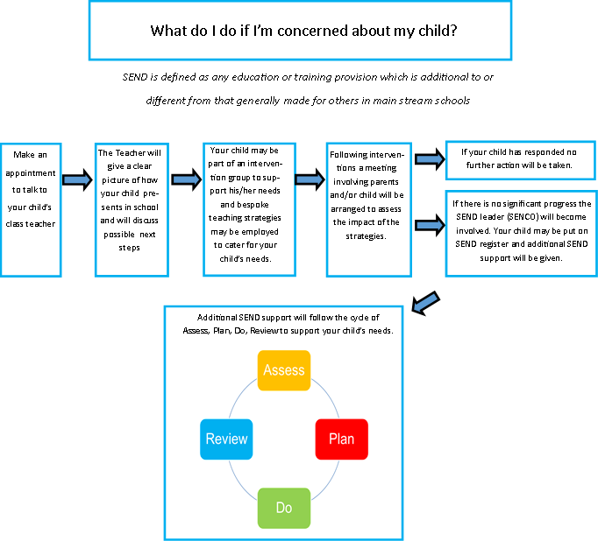

For more information on how Assess, Plan, Do, Review works watch this short video:
https://www.youtube.com/watch?v=1lsJveEuMHc&feature=youtu.be

Frequently Asked Questions

- What kinds of Special Educational Needs (SEND) does the school cater for?

Pakeman Primary School is a mainstream primary school and welcomes children and young people with SEND in one or more of the following areas:

- Communication and interaction
e.g. speech, language and communication needs (SLCN), Autism Spectrum Condition (ASC)

- Cognition and learning
e.g. Specific learning difficulties (SpLD), moderate learning difficulties (MLD), severe learning difficulties (SLD) global developmental delay, dyslexia, dyscalculia and dyspraxia, profound and multiple learning difficulties (PMLD)

- Social, emotional and mental health difficulties (SEMH)
e.g. attention deficit hyperactive disorder (ADHD), depression, eating disorders, attachment disorder

- SENDsory and/or physical needs
e.g. vision impairment (VI), hearing impairment (HI) or a multi-sensory impairment (MSI) or Cerebral Palsy (CP) epilepsy {Note – the building is not fully accessible to pupils with mobility difficulties. See section 6}

- Medical needs
Where pupils have medical needs and special educational needs, we will plan and deliver education provision in a co-ordinated way with their healthcare plan if they have one. We will also follow the statutory guidance on supporting pupils at school with medical conditions.

- What are the school's policies for the identification and assessment of pupils with special educational needs (SEND)?

All of our teachers teach children with SEND. All of our staff recognise the importance of identifying SEND early and making effective provision quickly. The identification and assessment of SEND is built into the school’s approach to monitoring the progress of all pupils.

We assess each pupil’s skills and levels of attainment when they first come to the school. This builds on the information from the child’s previous early years or school where appropriate and provides us with information we need to monitor their progress. It also ensures that we discover any areas of difficulty early on. Where children already have their SEND diagnosed or identified we will work closely with the family and our partners to make sure we know as much as possible about the child before they start at the school.

Teachers are supported by the Senior Leadership Team to regularly assess pupils’ progress. This helps us to see any pupils whose progress:

- is significantly slower than that of their peers starting from the same baseline
- fails to match or better their previous rate of progress
- fails to close the attainment gap between them and their peers

Where assessments show that a child is not making adequate progress, our first response is to make sure there is high quality teaching in place. Making high quality teaching normally available to the whole class is likely to mean that fewer pupils will require additional support.

If their progress continues to be slower than expected the teacher will work with the family and the SENDCO to carry out a clear analysis of the child’s needs and identify if they need additional support. There can be many reasons why a child doesn’t make the progress expected of them – perhaps there has been a significant change in family circumstances such as a new baby, a move of home, or the death of a relative. Or perhaps because they have a special educational need.

The school uses a range of different assessment tools and systems to help identify and assess pupils with SEND. The tools and assessments gradually draw upon more frequent reviews and more specialist expertise to understanding SEND and match interventions to the SEND of pupils. They are summarised in the diagram below:

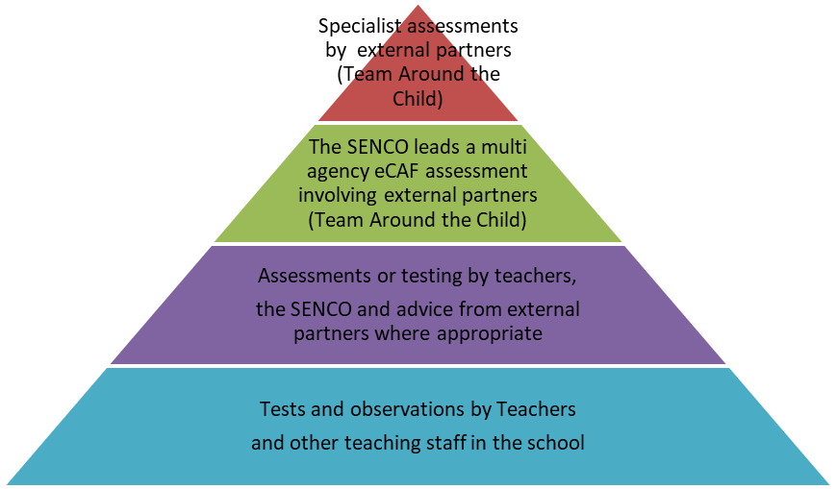

When considering if a child needs SEND support the school takes into account :

- the pupil’s previous progress and attainment
- the teacher’s assessment and experience of the pupil
- the pupil’s development in comparison to their peers and national data
- the views and experience of parents
- the pupil’s own views
- advice from external support services, where appropriate.

- What are the school’s policies for making provision for pupils with special educational needs (SEND), whether or not pupils have Education Health and Care Plans?

Most of our pupils with SEND have their needs met as part of high-quality teaching within ordinarily available provision. This may include teachers adapting what they do and having different approaches to meet different learning styles, personalised learning arrangements for different pupils and a range of interventions normally provided by the school.

If a pupil is identified (through the assessment process above) as having special educational needs, their teacher and SENDCO will consider everything we know about the pupil to determine the support that they need and whether it can be provided by adapting the school’s core offer or whether something different or additional is required.

Where provision for SEND is needed, we work with pupils and their families to plan what to do. This usually includes writing a plan of action using one of the SEND planning tools we have available to use. The tools we use are summarised below.

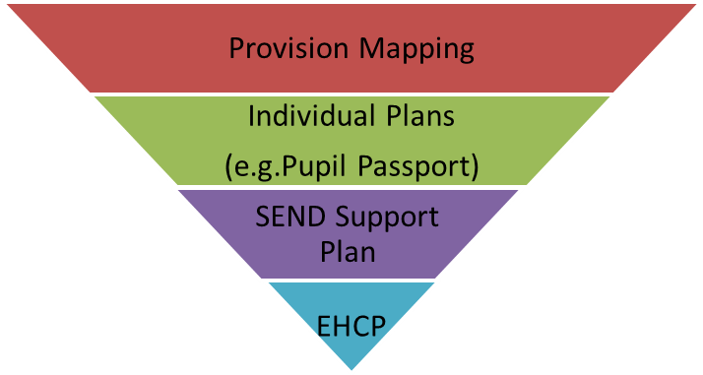
SEND Support

Provision Mapping: A document that is used to capture targeted and specialist interventions that will be ‘additional to’ and ‘different from’ the usual differentiated curriculum. An example of our Provision map is available here: Appendix 1

Pupil Passport : This is a 1 page profile with information about how your child learns with advice for supporting him/her. Example here: Appendix 4

SEND Support Plan: A document containing a 1 page profile and a detailed action plan listing the goals and provision to meet the SEND. Example here: Appendix 5

Education Health and Care Plan (EHCP) : Where the school has done everything it can to identify, assess and meet the SEND of the child and they are still not making the expected progress, the school or parents may consider requesting an Education, Health and Care assessment. The process for requesting an EHCP assessment in Islington can be found on the Council’s Local Offer website. www.islington.gov.uk/localoffer

Education Health and Care Plans are issued by the Local Authority where necessary and are used by the school to plan SEND provision for children with severe and complex needs. The EHP includes:
- a detailed profile of the child, their strengths and aspirations for the future
- any education, health and care needs they have
- the goals or outcomes for the pupil agreed by the family and professionals for the next phase of their education
- any education, health and social care provision in place to meet their needs

The EHCP includes a detailed annual support plan/action plan. This plan sets out the goals for the pupil for the next year, and the activities that everyone supporting the child will put in place to support them Example here: Appendix 5

The following table shows the number of pupils with SEND in the school in September 2024 and the type of tools we use to plan SEND provision:

SEND Planning Tool | Number of pupils
Provision Mapping | 54
Pupil Passport | 50pupils
SEND Support Plan | 4 pupils
Education Health and Care Plans (EHCP) | 15 pupils

- How does the school evaluate the effectiveness of its provision for SEND?

The quality of teaching is the most important factor in ensuring all pupils make progress. We regularly review the quality of teaching in the school and ensure that teachers are able to identify how individual children learn best and what support they need.

We test the effectiveness of our SEND provision by checking pupil progress and to see if the agreed goals and outcomes for a pupil are being met. Where professionals from health or social services are involved with the child we will ask for their help to inform and review progress, to make sure that all those supporting the family are working together effectively.

The teachers work with the SENDCO, the parents and the child to make sure any SEND support is adapted or replaced by another approach if it is not being effective.

The SENDCO and the head teacher report regularly to Governors on the quality of SEND provision and the progress towards outcomes being made by pupils with SEND. Governors also consider the attainment data for pupils with SEND and compare it with the progress of other pupils and the progress of pupils in similar schools. This helps to ensure that the approaches used to meeting SEND are based on the best possible evidence and are having the required impact on progress.

- What are the school’s arrangements for assessing and reviewing the progress of pupils with SEND?

Every pupil in the school has their progress reviewed regularly and this information will be shared with both parents and pupils. We provide an annual report to parents on their child’s progress, normally at the end of the school year.

Where a pupil is receiving SEND support, we provide feedback to parents more regularly. We may use home school books to give daily feedback on how a child has been at school that day. We also contact parents by phone or email where we have specific feedback or need to discuss specific achievements, concerns or observations. We also have a review meeting at least three times each year. Some pupils with SEND may have more frequent reviews if they are required.
This is called the Assess, Plan, Do, Review process.

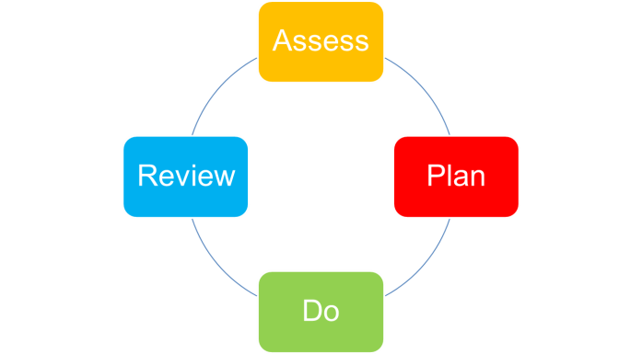

Reviews are usually led by a teacher with good knowledge and understanding of the pupil’s needs and attainment, usually the class teacher, supported where necessary by the SENDCO. Reviews normally last between 20 minutes and 1 hour, although this can vary if there has been good progress, the child’s needs have changed or the review involves a range of different professionals. We always aim to allow sufficient time to plan effectively.

Reviews involve the pupil, the family and other professionals where this is appropriate. They are used to:
- discuss what is working well and not working well
- find out if the SEND provision has been delivered as planned
- review the pupil’s progress towards their goals and longer term outcomes
- discuss and agree clear outcomes for the future
- discuss and agree the support needed
- share advice and information on the things that parents can do at home to reinforce or contribute to their child’s progress
- identify the actions needed to meet the agreed outcomes, the responsibilities of the parent, the pupil, the school, the local authority and other partners.

A record of the outcomes, action and support agreed through the discussion is then shared with all the appropriate school staff and the pupil’s parents. The annual review form for SEND support: Appendix 5
Annual review form for EHCP can be found here: Appendix 8

When the school has an Ofsted inspection the Inspectors take a particular interest in the progress of pupils with SEND. The school’s most recent OFSTED inspection can be found here:

https://reports.ofsted.gov.uk/provider/21/100418

- What is the school’s approach to teaching pupils with SEND?

All pupils, including those with SEND, have access to a broad and balanced curriculum. Teachers plan lessons carefully and think about the wide range of different needs in their class and use the information from assessments and progress reviews to set targets which are deliberately ambitious to encourage pupils to aim high. Teachers plan their lessons with the SEND of pupils in mind, which means that most pupils with SEND and disabilities will be able to study the full national curriculum along with their peers.

Teaching staff always aim to match the work given to pupils with their ability to do it. School staff such as Learning Support Assistants, Child and Family Support Workers and other more specialist staff, may be directed to work with pupils, in pairs or small groups and sometimes individually.

The type of SEND support provided is based on reliable evidence of what works. We are careful to avoid the over reliance of individual support for pupils as evidence shows that in many cases this prevents them becoming independent learners.

The SENDCO, supported by the Senior Leadership Team, ensures that staff have sufficient skills and knowledge to deliver the interventions that pupils need.

- How does the school adapt the curriculum and learning environment for pupils with SEND?

We are committed to meeting the needs of all pupils including those with SEND. We have a duty not to directly or indirectly discriminate against, harass or victimise disabled children and young people. We make all reasonable adaptations to the curriculum and the learning environment to make sure that pupils with SEND are not at a substantial disadvantage compared with their peers.

We work closely with families and partners to work out what disabled children and young people might need before they start with us, and what adjustments we might need to be make. We discuss with families what we can do to adapt the curriculum and/or the building as necessary, and in order to getting additional resources and support.

Teachers will be supported by the SENDCO to assess, plan and differentiate the curriculum or make adaptations to meet the needs of pupils with SEND. This may also involve working with outside partners. For example we might need to:
:
- Provide visual resources to support learning
- rearrange the layout of the classroom
- create a quiet area in the school
- buy specialist ICT software
- identify appropriate ancillary aids and assistive technology and support the families application for funding to purchase the equipment.

In considering what adaptations we need to make the SENDCO will work with the head teacher and school governors to ensure that the school meets its responsibilities under the Equality Act (2010) with regard to reasonable adjustments and access arrangements. A link to the Equality Act 2010 can be found here: http://www.legislation.gov.uk/ukpga/2010/15/contents

Further information explaining how we meet the duty can be found in our Equality Policy:

https://www.pakemanprimary.co.uk/school-info/school-policies/

e) What additional support for learning is available to pupils with SEND?

The school organises the additional support for learning into 3 different levels (also called waves).

Wave 1 (Universal): describes quality inclusive teaching which takes into account the learning needs of all the children in the classroom. This includes providing differentiated work and creating an inclusive learning environment.

Wave 2 (Targeted): describes specific, additional and time-limited interventions provided for some children who need help to accelerate their progress to enable them to work at or above age-related expectations. Wave 2 interventions are often targeted at a group of pupils with similar needs.

Wave 3 (Specialist): describes targeted provision for a minority of children where it is necessary to provide highly tailored intervention to accelerate progress or enable children to achieve their potential. This may include specialist interventions.

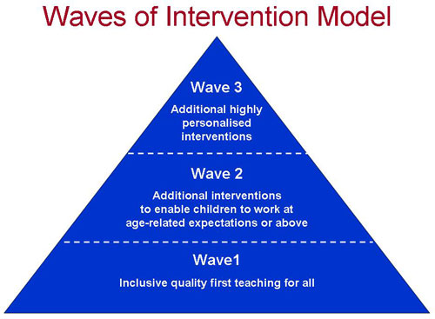
The provision available at each level (or wave) is summarised in our provision map here: Appendix 1

We provide additional support for pupils with SEND to be able to access exams, when needed.

We are able to support the administration of medication if it is recommended by health professionals.

f) What extra-curricular activities are available for pupils with SEND?

The school has a wide range of extra circular activities including:
- A breakfast club each morning between 8am – 8:45am
- Lunchtime clubs
- After school clubs including play centre, phonics, sports, street dance, DJ club, gardening, cooking, Lego club, arts and music activities

The current list of activities for this term can be found in the school office.

We try to make sure that all pupils with SEND can engage in these activities of the school alongside pupils who do not have SEND. Where it is agreed that taking part in these activities will contribute significantly to meeting the agreed outcomes for a pupil with SEND the school will normally be able to pay for any training, resources or equipment that may be needed.

The school also provides opportunities for pupils to go on school trips and we organise an annual residential trip for years 5 and 6. We will involve parents of pupils with SEND in the planning of school trips and residential to assess the benefits and risks and identify how the needs of individual pupils can be best met.

The school also provides access to childcare through after school play centre that delivers term time after school childcare. If there are barriers to children with SEND accessing this childcare, the school will work with the family, the provider and other partners to identify any appropriate actions and resources to address these barriers.

g) What support is available for improving the emotional and social development of pupils with SEND?

The culture and structures within the school aim to encourage the emotional and social development for all pupils, including those with SEND.

We work hard to create a culture within the school that values all pupils, allows them to feel a sense of belonging and makes it possible to talk about problems in a non-stigmatising way. We have clear policies on behaviour and bullying that set out the responsibilities of everyone in the school. We have clear systems and processes so that staff can identify and respond to mental health difficulties.

For children with more complex problems, additional in-school interventions may include:

- advice and support to the pupil’s teacher - to help them manage the pupil’s behaviour within the classroom, taking into account the needs of the whole class

- small group sessions - to promote positive behaviour, social development and self-esteem

- individual plans - to support pupils during transition periods, break times
- additional support for the pupil – to help them cope better within the classroom
- Place to Talk – support from our Place to Be Therapist provided at lunchtimes
- therapeutic work with the pupil, delivered by specialists (within or beyond the school), which might take the form of cognitive behavioural therapy, behaviour modification or counselling approaches, family support and/or therapy by health professionals – to help the child and their family better understand and manage behaviour.
For further information please see our behaviour management policy.
- Who is the SEND Co-Ordinator and how do I contact them?

Our Special Education Needs Coordinator (SENDCO) is a qualified teacher working at the school who has responsibility for SEND. They work closely with the head teacher and governing body as well as all teachers. If you have concerns about your child you should speak to your child’s teacher before you speak to the SENDCO.

The SENDCO is responsible for:

- overseeing the day-to-day operation of the school's SEND policy
- coordinating provision for children with special educational needs
- liaising with and advising fellow teachers
- overcoming barriers to learning and sustaining effective teaching
- managing teaching assistants
- overseeing the records of all children with SEND
- liaising with parents of children with SEND
- planning successful movement (transition) to a new class group or school
- providing specialist advice and facilitating training to ensure that all staff are skilled and confident about meeting a range of needs
- liaising with external agencies including the LA’s support and educational
psychology services, health and social services, and voluntary bodies

Tracey Gulliford - Special Educational Needs Coordinator (SENDCO for short)
Email: tgulliford@pakeman.islington.sch.uk
Phone: 0207 607 2575

You can request a meeting with the Tracey by email or phone. Tracey is also available in the school playground most mornings.

- What expertise and training does the school staff have in relation to SEND and how will specialist expertise be secured?

The school supports its staff to access a wide range of information on appropriate interventions for pupils with different types of need, and to access associated training to ensure they have the necessary knowledge and expertise.

The responsibility for ensuring staff have the appropriate training and expertise to meet the needs of pupils with SEND training is shared between the Head teacher, SENDCO and the Governing body. We closely monitor the training and development needs of our staff through annual appraisal.

The following tables show the training and expertise of the school staff.

General SEND training for all staff

Details of training / expertise | % of school staff trained
General First Aid | 100%
Paediatric First Aid | 15%
How to support pupils on the autistic spectrum; AET level 1 training | 100%
Introduction to speech and language | 100%
Asthma and Emergency Medication Training | 100%

Specific SEND training and expertise

Details of training / expertise | School staff
Accredited SENDCO (National Award) | SENDCO
Every Child a Talker | 2 Class Teachers
Introduction to Makaton | 1 teacher  3 teaching assistants
Jigsaw Learning Mentor | 1
Word Aware Training | All staff
EYFS Autism Training | 7 members of EYFS team
ELKLAN accredited teacher | 1 teacher
Introduction to Autism Spectrum Condition | All staff
Shape Coding | All staff
Zones of Regulation | All staff
ELSA (Emotional Literacy Support Assistant) | 2 Child and Family Support Workers

Specialist SEND Training (for specific children)

Details of training/ expertise | School staff trained
Positive handling | 18 members of staff

Our staff also access training and materials provided through outreach services offered to mainstream schools by each of Islington’s special schools. SEND training and expertise will be sought when the needs of individual children require it, for example when there is a need to prepare for a child coming to the school. This can include:

- Reading about the conditions
- Visits to other schools to see good practice
- Home visits
- Training by the Complex Care Nursing Team

Our links to external organisations with specialist training and expertise are listed in Appendix 3:

- What equipment and facilities are available to support pupils with SEND?

Pakeman Primary School is a flat site at pavement level with 3 playgrounds that are all at the same level and are step free. The school buildings consist of a main three-storey block, a separate one-storey nursery block, a Lodge, science lab and 2+ Centre. Whilst nursery and reception classrooms are on the ground floor all other year groups are on the middle and top floors. There are 2 separate flights of stairs to all floors but no lifts. There is a disabled toilet. The school office is on the ground floor.

Equipment available in our school to all children at any time needed:

- Audio books for group readers
- Communication books (for home and school)
- Sensory equipment
- Devices for additional recording e.g. Cameras, video recorders, voice recorders
- SEND software - Communication in Print to produce printed matter with visual prompts and specific maths and literacy computer programmes

The school will consider purchasing other equipment if there is an agreed identified need. We will normally consider this at the pupil’s termly or annual review.

In the past we have worked with partners to purchase specialist equipment tailored for an individual including:

- Personal laptops / iPads
- Move and sit cushion
- Specialist hand writing equipment
- Noise cancelling headphones

- What are the arrangements for consulting and involving parents of children with SEND in their child’s education?

All parents are encouraged to contribute to their child’s education through:

- discussions with the class teacher
- setting and reviewing targets
- parents’ evenings
- during discussions with the SENDCO or other professionals
- commenting and contributing to assessment, planning and reviews

If your child has an Education, Health and Care plan we will discuss their progress with you every term and have a formal review with you and your child at least annually. Further information about reviews can be found in question 3b above.

Specific support to help you support your child at home will include;

- Meetings with teachers and SEND staff to discuss progress and support including ideas for home.
- Parents as Educators programmes e.g. maths workshops, Early years workshops on maths, Early writing, phonics and reading

If we think your child needs significant amounts of extra support we will always discuss this with you and, where appropriate, a meeting with the parents and the people supporting your child can be arranged.

Where required we will arrange interpreters to enable parents to fully participate in formal meetings.

We have parents and Parent Governors who are happy to talk with prospective parents to share their experience and answer any questions you may have; if you would like to talk with one of them please contact the SENDCo. We run regular Coffee Mornings for parents and carers to discuss their children and speak with members of staff and outside agencies.

- What are the arrangements for consulting and involving pupils with SEND in their education?

Engaging all pupils as active participants in their own education and in making a positive contribution to their school and local community is a priority for the school. All children are consulted about their learning and how they feel about a range of topics annually before the spring term parents’ meeting. A summary of these findings are discussed with parents at the parents meetings.

Where pupils have SEND, we will take extra care to involve them and make sure their voice is heard. Their involvement will be tailored to each child and take into account their preferred methods of communication. This may include:

- providing them with relevant information in accessible formats

- using clear ordinary language and images rather than professional jargon

- giving them time to prepare for discussions and meetings
- dedicating time in discussions and meetings to hear their views
- involving the pupil in all or part of the discussion itself, or gathering their views as part of the preparation

- supporting their access to an adult who can help them express their views where necessary (this could be a family member or a professional)
- ensuring staff are skilled in working with children, parents and young people to help them make informed decisions and have access to training so they can do this effectively

We ensure that pupils with SEND are included and represented in the groups and activities that we have set up to listen to the views of pupils and involve them in decision-making. These groups and activities include:
- The School Council
- Annual pupil survey

The views of the individual child and young person sit at the heart of the SEND assessment and planning process. We will make sure that assessments include the wishes and feelings of the child, their aspirations, the outcomes they wish to seek and the support they need to achieve them. Whenever possible, we include pupils with SEND in planning how best to support them, and in reviewing their progress. This may include the use of questionnaires, story boards or symbols.

All pupils with SEND will have specific goals and outcomes and they will be part of the discussion to agree and review these. Where a personal budget is being used for those with an EHCP, the school will support the child’s involvement in decisions about their support.

- What are the arrangements for parents raising concerns and making a complaint about the SEND provision at the school?

We are committed to providing excellent services to all our children and their parents and we believe the best way to do this is to listen to your views. We encourage parents to contact us about their concerns and not to wait for the next formal opportunity to meet. So if you have something to tell us, whether good or bad, please contact the class teacher or SENDCO.

If you have a complaint about SEND provision, please tell us promptly by contacting the following people in this order;
- the class teacher
- the SENDCo (details below)
- The head teacher – using the main school number
- The SEND governor (a letter can be submitted through school office)

The SEND governor will then refer to the complaints procedure to try and address the issue.

Further information about our complaints procedure can be found through the school office or on the school website.

We realise that parents can sometimes find schools a bit scary and may need someone to help them approach us if things aren’t going well. If you need support to raise a concern or make a complaint this you may want to contact Islington Parent Carer Support Service, (SENDDIAS) an independent organisation that provides a mediation and support service. You can contact them on 020 3031 6651 or 020 3031 6652 or email islingtonsend@family-action.org.uk

As a matter of last resort parents can also make a formal complaint to Ofsted: guidance for parents can be found here http://www.ofsted.gov.uk/schools/for-parents-and-carers/how-complain, or by phone on 0300 123 4666.

Further information on local support for families of pupils with SEND can be found in the Local Offer. See question 13 below.

- How does the school involve others in meeting the needs of pupils with SEND and in supporting the families of such pupils?

Where a pupil continues to make less than expected progress, despite evidence-based support and interventions that are matched to the pupil’s area of need, we seek advice and support from specialists from outside agencies such as:
- educational psychologists
- School Well-Being Service
- Child and Adolescent Mental Health Services (CAMHS)
- specialist teachers
- therapists (including speech and language therapists, occupational therapists, art therapists and physiotherapists)
- Social workers

We always involve parents in any decision to involve specialists.

The SENDCO is the person who usually coordinates the contact and works with these outside agencies. We mainly use other agencies outside of the school to:

- help us train staff e.g. epilepsy and diabetes ,tube feeding,
- get more specialised advice e.g. advice on hearing impairment
- carry out assessments e.g. a social care assessment
- ask for a service to be delivered e.g. physiotherapy
- setting programmes for implementation at home and in school
- review progress and plan provision e.g at annual reviews

The main agencies used by the school are shown in Appendix 3.

We run coffee mornings in which we invite parents/carers to come and meet some of the different outside agencies with whom we work.

- What local support is there for the parents of pupils with SEND?

Information about local support in Islington is called The Local Offer and is located here: www.islington.gov.uk/localoffer

The Family Information Service - 020 7527 5959
Gives free impartial information, advice and guidance about services for children, young people and families.
email fis@islington.gov.uk
Website: www.islington.gov.uk/fis

The Special Educational Needs Community Support Service (SENDDIAS)
is based at Family Action, Northern Health Centre, 580 Holloway Rd, Islington, London N7 6LB:
Offers a range of services to assist the parents/carers of children with SENDD. These include:
- Advice, information and support on Education, health and social care issues
- Support to express your views and wishes
- Support at meetings with schools and the Local Authority
- Help to complete SEND and Disability related paper work
- Supporting young people up to 25 in their own right
- Signposting to other services

Tel no 0203 316 1930
Website www.family-action.org.uk
Email islingtonsend@family-action.org.uk

- What are the school’s arrangements for supporting pupils with SEND when they join the school, and supporting them to move to secondary school / further education, training or employment/ adulthood and independent living?

All children and young people with SEND and their families may be particularly anxious about changing classes or “moving on” from school to school. We work with families and our partner organisations to make sure changes are planned and well managed.

Transition guide table:

 | Additional arrangements for children with SEND (examples)
In to nursery / Reception | - Swift transfer of records  - Home visit  - Work with Islington’s Early Years Inclusion Team  - Transition meeting with the previous setting  - Transition plan drawn up with main carer and your child (could include managed visits, pictures or transition book or video, social stories about ‘moving on’)
When moving to another school | - We will contact the School SENDCO and share information about the special arrangements and support that has been made to help your child achieve their learning goals.  - Swift transfer of records  - Transition meeting with the new setting  - Transition plan (as above)
When moving groups/ forms/ classes in school | - Transition meetings are held within school with the new class teacher.  - Work with child to prepare for the next class through: Transition books, transition programme, visual supports and visits to the next setting. This will be shared with parents and transition books that can be taken home over the holidays.
Primary to Secondary transition | - Swift transfer of records  - Year 5 annual reviews planning meeting  - During Year 6 the SENDCO will attend the Secondary Transfer Conference to discuss the specific needs of your child, and the nature and level of support which has had the most impact, with the secondary school they will be transferring to  - Additional multi-agency meetings will be arranged to create a more detailed “transition” plan which may include more visits to the new school and/or additional visits from the new school for the children where these changes are more complex

- Where can I find more information about SENDD services in Islington and the local area (the Local Offer)?

All Local authorities must publish a Local Offer, setting out in one place information about provision they expect to be available across education, health and social care for children and young people in their area who have SEND or are disabled.

The Local Offer has two key purposes:

- to provide clear, comprehensive and accessible information about the available provision and how to access it
- to make provision more responsive to local needs and aspirations by directly involving disabled children and those with SEND and their parents, and disabled young people and those with SEND, and service providers in its development and review

The school cooperates with the Local Authorities in the local area to:

- make families aware of the kind of support available to them and where to find the Local Offer
- help people access the Local Offer information, especially where there are barriers to them accessing it. This can include helping them to access the internet, printing off pages, explaining, interpreting and
- consult children and young people and their families directly in preparing and reviewing the Local Offer
- keeping the Local Offer information up to date and identifying gaps in provision
To find out more about the range of services on offer locally go to:

Islington Local Offer: www.islington.gov.uk/localoffer
Camden Local Offer: www.localoffer.camden.gov.uk
Hackney’s Local Offer: www.hackneylocaloffer.co.uk
Haringey Local Offer: www.haringey.gov.uk/children-and-families/children-and-young-people-special-educational-needs-and-disabilities-our-local-offer

