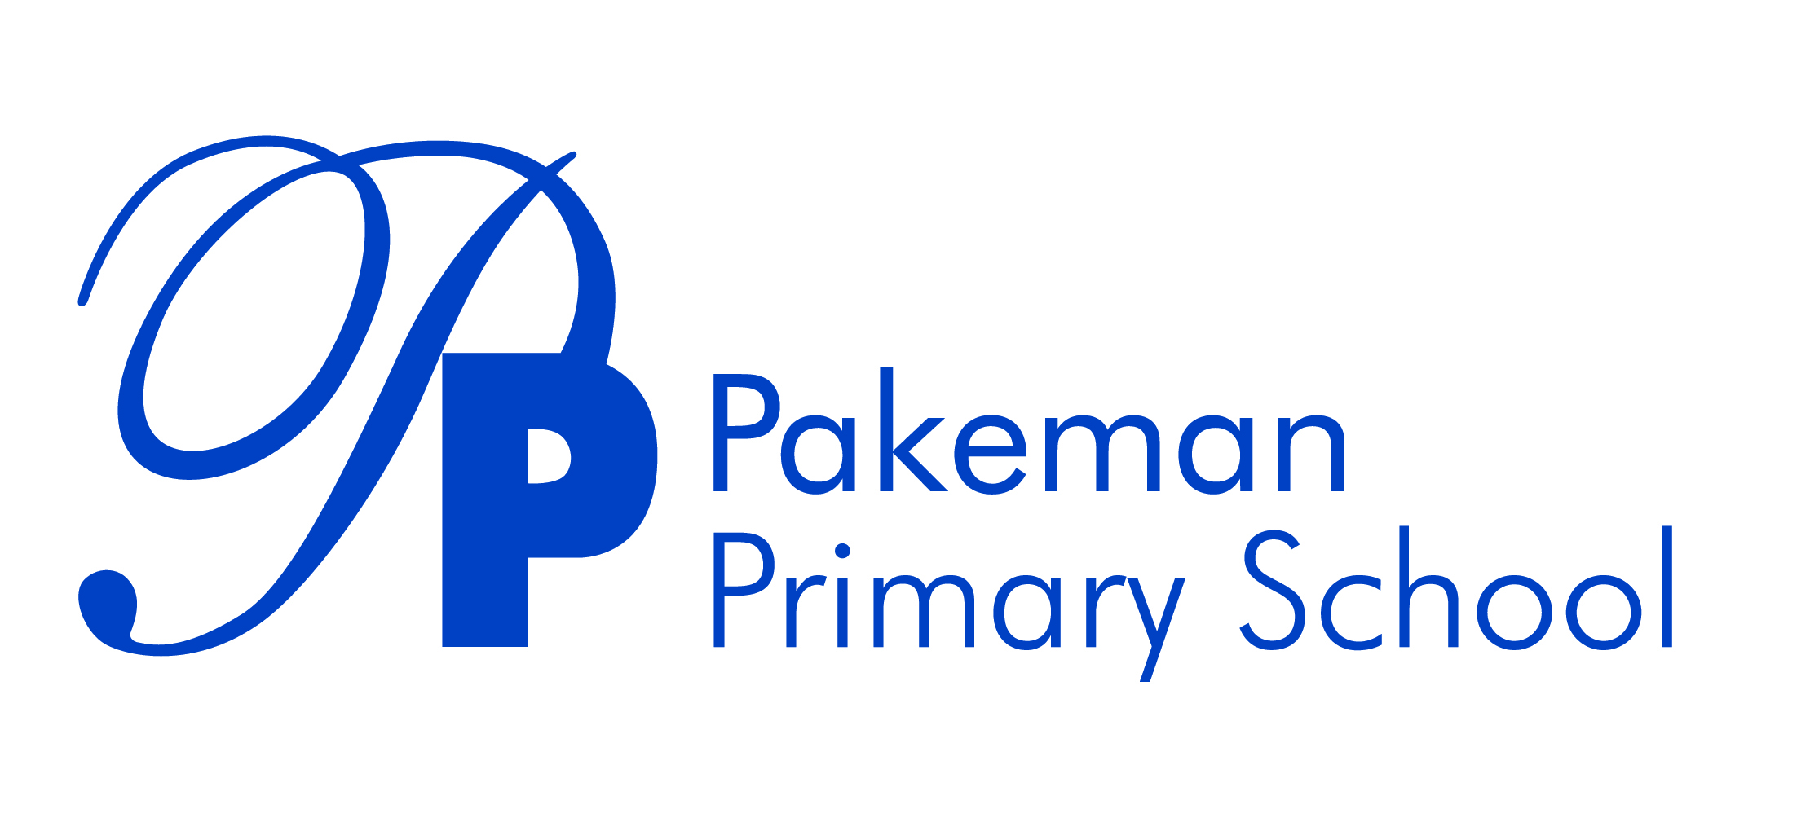

**Uniform Policy**

**Review Date: September 2024**

**Next Review Date: September 2025**

_________________________ _______________________

Emma Bonnin Date

Headteacher

**_________________________ _______________________**

Laura Popazzi Date

Chair of governors

**Statement of Values and Ethos Statement**

At Pakeman Primary School, we aim to inspire excellence and raise the attainment of all our children in a positive, safe, and nurturing environment, where learning, teaching and diversity are valued.

This policy has been written to support our values. All staff, volunteers and students are expected to follow it.

**1. Aims**

This policy clarifies our expectations for school uniform. We aim to have a uniform that is of reasonable cost for parents and carers. The policy also explains how we will avoid discrimination in line with our legal duties under the Equality Act 2010

# **2. Our school’s legal duties under the Equality Act 2010**

The [Equality Act 2010](https://www.legislation.gov.uk/ukpga/2010/15/contents) prohibits discrimination against an individual based on the protected characteristics, which include age, disability, gender reassignment, marriage and civil partnership, pregnancy and maternity, race, religion or belief, sex, and sexual orientation. To avoid discrimination, our school will:

* Avoid listing uniform items based on sex, to give all pupils the opportunity to wear the uniform they feel most comfortable in or that most reflects their self-identified gender
* Make sure that our uniform costs the same for all pupils
* Allow all pupils to have long hair (though we reserve the right to ask for this to be tied back)
* Allow all pupils to style their hair in the way that is appropriate for school yet makes them feel most comfortable
* Allow pupils to request changes to swimwear for religious reasons
* Allow pupils to wear headscarves and other religious or cultural symbols
* Allow for adaptations to our policy on the grounds of equality by asking pupils or their parents/carers to get in touch with the headteacher, who can answer questions about the policy and respond to any requests

# **3. Limiting the cost of school uniform**

Our school has a duty to make sure that the uniform we require is affordable and in line with statutory [guidance](https://www.gov.uk/government/publications/cost-of-school-uniforms/cost-of-school-uniforms) from the Department for Education on the cost of school uniform. We will make sure our uniform is available at a reasonable cost and that it provides the best value for money for parents/carers. We will do this by:

* Limiting any items with distinctive characteristics where possible
* Considering cheaper alternatives to school-branded items, such as logos that can be ironed on
* Avoiding specific requirements for items pupils could wear on non-school days, such as coats, bags and shoes
* Keeping the number of optional branded items to a minimum, so that the school’s uniform can act as a social leveler
* Avoiding frequent changes to uniform specifications and minimising the financial impact on parents/carers of any changes. This includes avoiding different uniform requirements for different year groups
* Avoiding different uniform requirements for extra-curricular activities
* Considering alternative methods for signaling differences in groups for interschool competitions, such as creating posters or labels
* Ensuring that arrangements are in place for parents/carers to acquire second-hand uniform items
* Consulting with parents/carers and pupils on any proposed significant changes to the uniform policy and carefully considering any complaints about the policy

# 

# **4. Expectations for school uniform and where to purchase it**

School uniform expectations are as follows:

* All pupils must wear a Pakeman School polo shirt and a Pakeman Primary School sweatshirt, cardigan or fleece
* All polo shirts, jumpers, cardigans and fleeces must be navy blue and have the Pakeman Primary School logo
* All pupils must wear dark grey, black or navy trousers, skirts, tracksuit bottoms or leggings
* Headscarves must be dark grey, black or navy
* In hot weather dark grey, black or navy shorts and blue summer dresses can be worn
* Trainers and school shoes can be worn. Open toe footwear, heels or wheels-on-shoes are not allowed
* For PE lessons, all pupils must weath a white T-shirt and dark grey, black or navy shorts/tracksuit bottoms or leggings. Children can come to school in their PE kits on the days that they have PE lessons
* For safety reasons, children are not permitted to wear jewellery at school. Plain stud earrings are allowed.

Our uniform supplier is School Uniform Scotland. The prices of school uniform items are the same for all sizes. Please speak to the school office for current prices of uniform/delivery costs. Second hand uniform sales happen throughout the year and will be advertised in the school newsletter and via text to parents/carers.

**5. Expectations for our school community**

**5.1 Pupils**

Pupils are expected to wear the correct uniform at all times (other than specified non-school uniform days). This includes: whilst pupils are on school premises, travelling to and from school, and at out-of-school events or on trips that are organised by the school. Pupils/parents/carers can contact the headteacher if they want to request an amendment to the uniform policy in relation to their protected characteristics.

**5.2 Parents and carers**

* Parents/carers are expected to make sure their child has the correct uniform and PE kit, and that every item is clean, clearly labelled with the child’s name and in good condition.
* Parents/carers are also expected to contact the headteacher if they want to request an amendment to the uniform policy in relation to their child’s protected characteristics or due to the cost of the uniform.
* Parents/carers are expected to lodge any complaints or objections relating to the school uniform in a timely and reasonable manner. Disputes about the cost of the school uniform will be resolved locally and dealt with in accordance with our school’s complaints policy. The school will work closely with parents/carers to arrive at a mutually acceptable outcome.

**5.3 Staff**

Staff will closely monitor pupils to make sure they are in the correct uniform. They will discuss with parents/carers if a pupil isn’t wearing the correct uniform, but will follow up with the headteacher if the situation doesn’t improve. In cases where it is suspected that financial hardship has resulted in a pupil not complying with this uniform policy, staff will take a mindful and considerate approach to resolving the situation.

**5.4 Governors**

The governing board will review this policy and make sure that it is appropriate for our school’s context, is implemented fairly across the school, takes into account the views of parents/carers and pupils, and offers a uniform that is appropriate, practical and safe for all pupils. The board will also make sure that the school’s uniform supplier arrangements give the highest priority to cost and value for money, for example by avoiding single supplier contracts and by re-tendering contracts at least every 5 years.

# **6. Monitoring arrangements**

This policy will be reviewed yearly by the headteacher and the office staff. At every review, it will be approved by the Chair of Governors.