Dear parents/carers,

It’s nearly time to go back to school! I hope you have all had a restful and enjoyable summer holiday.

Below is a reminder of our Pakeman School uniform:

    - All Pakeman School uniform is available on https://schooluniformscotland.com/products/Pakeman-Primary-c87660071
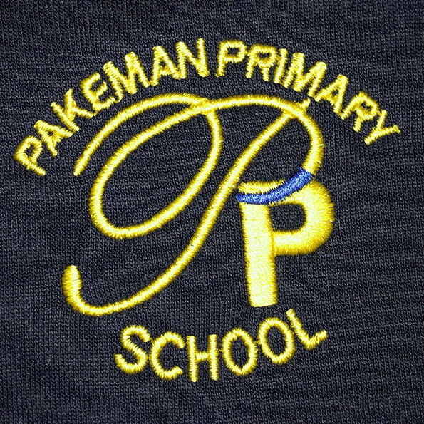
- All polo shirts, jumpers, cardigans and fleeces must have the Pakeman School logo.
- All pupils must wear a Pakeman School polo shirt and a Pakeman School sweatshirt, cardigan or fleece.
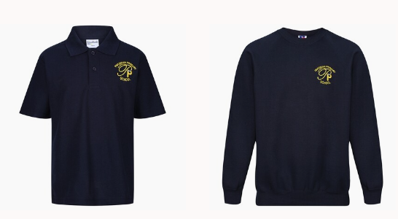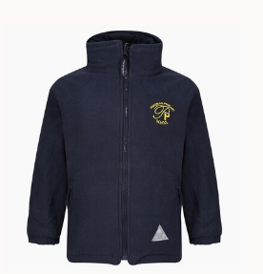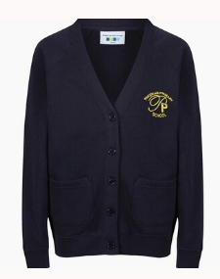

- All pupils must wear dark grey, black or navy trousers, skirts, tracksuit bottoms or leggings.
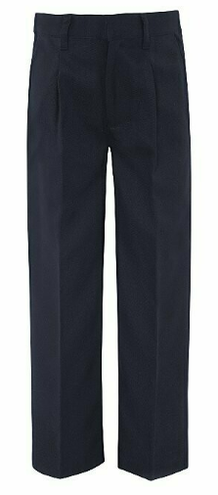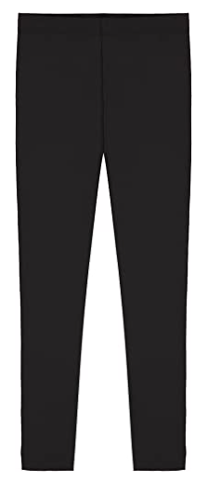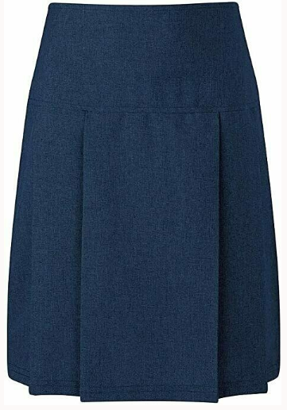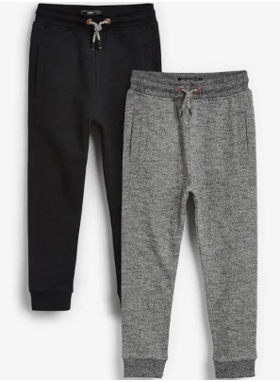

- Headscarves must be dark grey, black or navy.
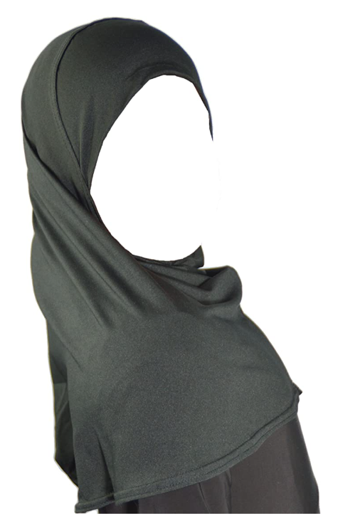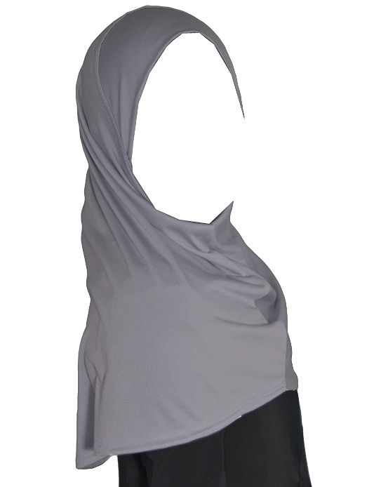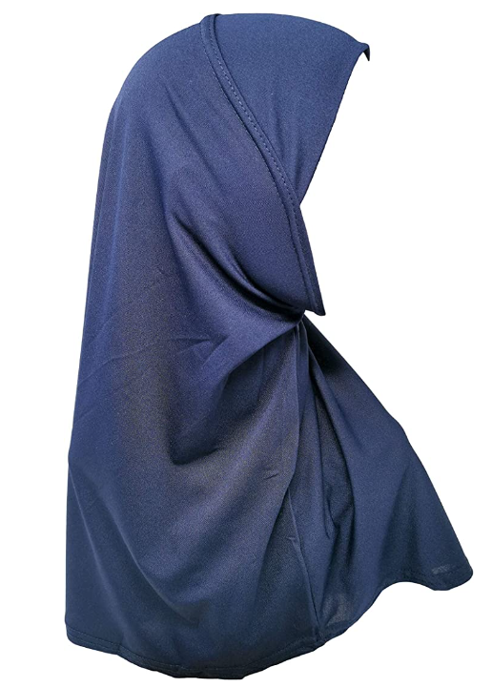

- In hot weather dark grey, black or navy shorts and blue summer dresses can be worn.
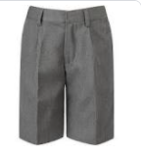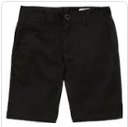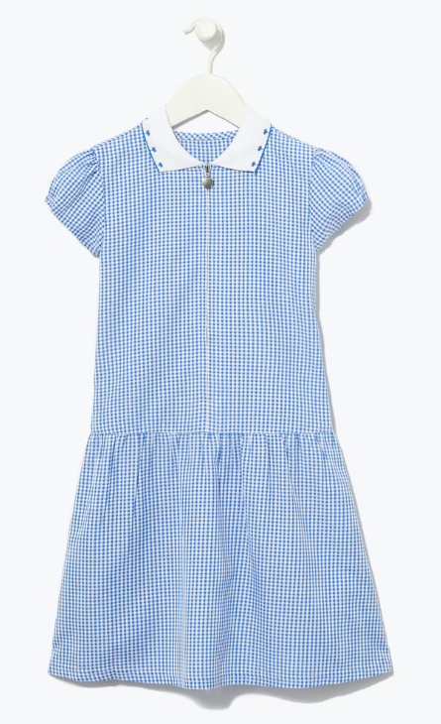

- Open toe footwear is not allowed.

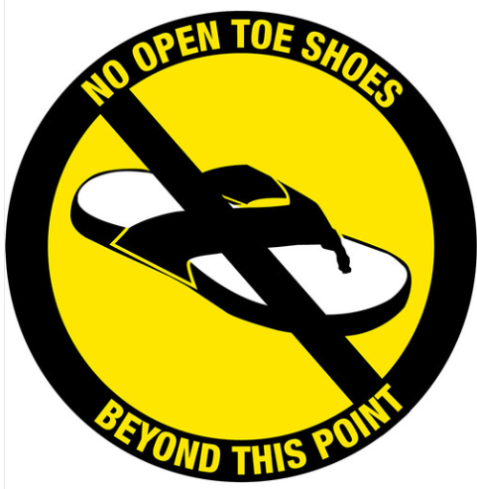

- For PE lessons, all pupils must wear a white tee shirt and dark grey, black or navy shorts/ tracksuit bottoms or leggings. Children can come to school in their PE kits on the days that they have PE lessons.
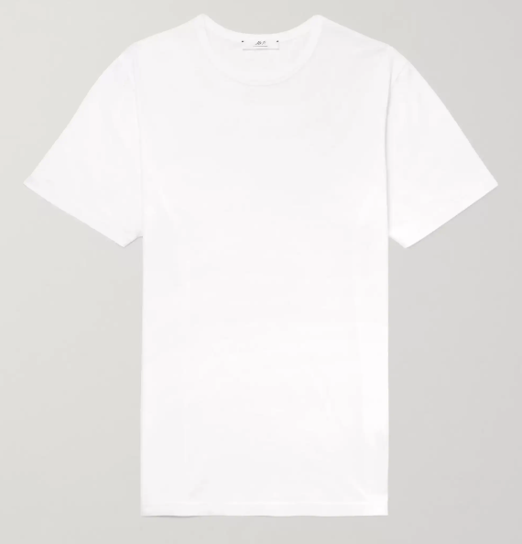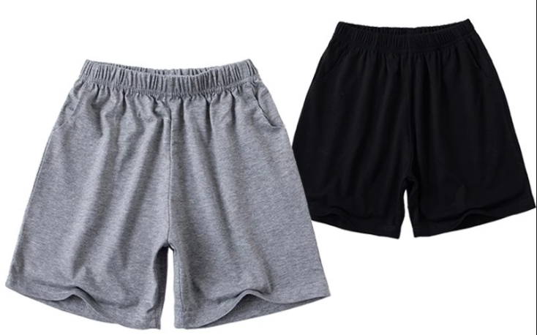

We look forward to seeing you at school very soon.
Thank you.
Emma

