Pakeman Primary School
2024-2025

SCHOOL VALUES/ SCHOOL RULES
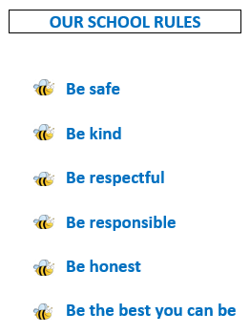
SCHOOL MOTTO
Be the best you can be.

SCHOOL VISION AND INTENT
Vision (Where to in the future)
We aim to inspire excellence and raise the attainment of all our children in a positive, safe and nurturing environment, where learning, teaching and diversity are valued.

Intent (How to reach the vision)

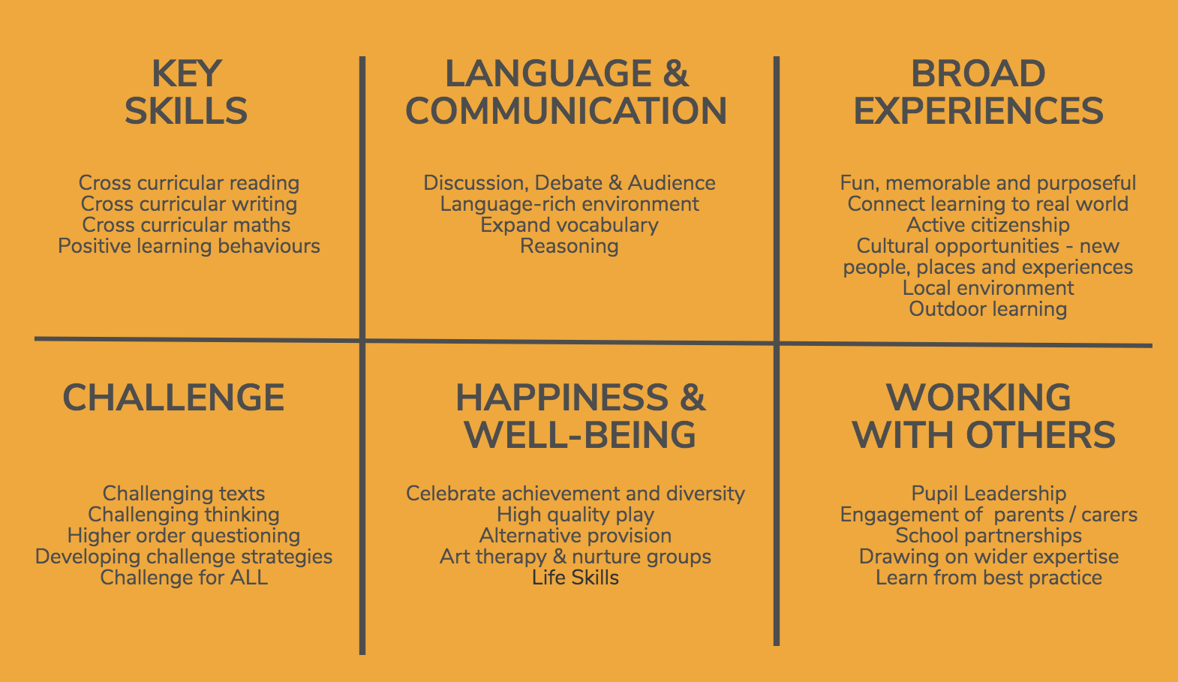
SCHOOL IMPROVEMENT PLAN PRIORITIES (SIP)
